


Operate a fast food outlet
D1.HCA.CL3.05
Trainee Manual


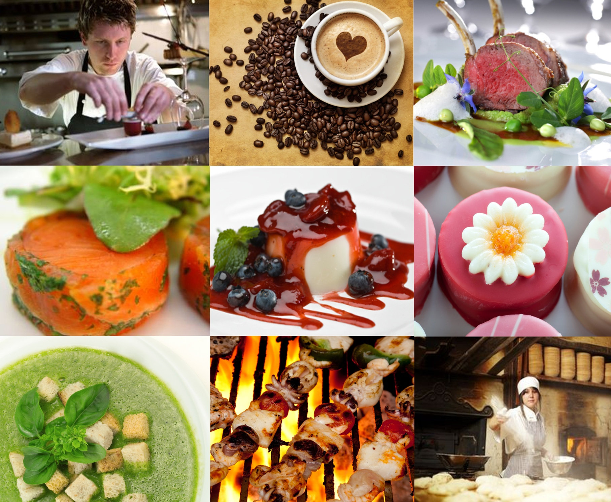



Operate a fast food outlet

D1.HCA.CL3.05

Trainee Manual





Project Base
William Angliss Institute of TAFE
555 La Trobe Street
Melbourne 3000 Victoria
Telephone: | (03) 9606 2111
Facsimile: | (03) 9670 1330
Acknowledgements
Project Director: | Wayne Crosbie
Chief Writer: | Alan Hickman
Subject Writer: | Garry Blackburn
Project Manager | Alan Maguire
Editor: | Jim Irwin
DTP/Production: | Daniel Chee, Mai Vu, Kaly Quach
The Association of Southeast Asian Nations (ASEAN) was established on 8 August 1967. The Member States of the Association are Brunei Darussalam, Cambodia, Indonesia, Lao PDR, Malaysia, Myanmar, Philippines, Singapore, Thailand and Viet Nam.
The ASEAN Secretariat is based in Jakarta, Indonesia.
General Information on ASEAN appears online at the ASEAN Website: www.asean.org.
All text is produced by William Angliss Institute of TAFE for the ASEAN Project on “Toolbox Development for Front Office, Food and Beverage Services and Food Production Divisions”.
This publication is supported by the Australian Government’s aid program through the ASEAN-Australia Development Cooperation Program Phase II (AADCP II).
Copyright: Association of Southeast Asian Nations (ASEAN) 2013.
All rights reserved.
Disclaimer
Every effort has been made to ensure that this publication is free from errors or omissions. However, you should conduct your own enquiries and seek professional advice before relying on any fact, statement or matter contained in this book. The ASEAN Secretariat and William Angliss Institute of TAFE are not responsible for any injury, loss or damage as a result of material included or omitted from this course. Information in this module is current at the time of publication. Time of publication is indicated in the date stamp at the bottom of each page.
Some images appearing in this resource have been purchased from stock photography suppliers Shutterstock and iStockphoto and other third party copyright owners and as such are non-transferable and non-exclusive. Clip arts, font images and illustrations used are from the Microsoft Office Clip Art and Media Library. Some images have been provided by and are the property of William Angliss Institute.
Additional images have been sourced from Flickr and SKC and are used under Creative Commons licence: http://creativecommons.org/licenses/by/2.0/deed.en
File name: TM_Operate_a_fast_food_outlet_FN_030214





Table of contents
Introduction to trainee manual 1
Unit descriptor 3
Assessment matrix 5
Glossary 7
Operating a fast food outlet 11
Element 1: Plan for fast food production 13
Element 2: Prepare, cook and hold items for fast food outlet 33
Element 3: Provide fast food service 47
Element 4: Maintain fast food outlet 55
Element 5: Store food items 69
Presentation of written work 81
Recommended reading 83
Trainee evaluation sheet 85
Trainee Self-Assessment Checklist 87

Introduction to trainee manual

To the Trainee
Congratulations on joining this course. This Trainee Manual is one part of a ‘toolbox’ which is a resource provided to trainees, trainers and assessors to help you become competent in various areas of your work.
The ‘toolbox’ consists of three elements:
- A Trainee Manual for you to read and study at home or in class
- A Trainer Guide with Power Point slides to help your Trainer explain the content of the training material and provide class activities to help with practice
- An Assessment Manual which provides your Assessor with oral and written questions and other assessment tasks to establish whether or not you have achieved competency.
The first thing you may notice is that this training program and the information you find in the Trainee Manual seems different to the textbooks you have used previously. This is because the method of instruction and examination is different. The method used is called Competency based training (CBT) and Competency based assessment (CBA). CBT and CBA is the training and assessment system chosen by ASEAN (Association of South-East Asian Nations) to train people to work in the tourism and hospitality industry throughout all the ASEAN member states.
What is the CBT and CBA system and why has it been adopted by ASEAN?
CBT is a way of training that concentrates on what a worker can do or is required to do at work. The aim is of the training is to enable trainees to perform tasks and duties at a standard expected by employers. CBT seeks to develop the skills, knowledge and attitudes (or recognise the ones the trainee already possesses) to achieve the required competency standard. ASEAN has adopted the CBT/CBA training system as it is able to produce the type of worker that industry is looking for and this therefore increases trainees chances of obtaining employment.
CBA involves collecting evidence and making a judgement of the extent to which a worker can perform his/her duties at the required competency standard. Where a trainee can already demonstrate a degree of competency, either due to prior training or work experience, a process of ‘Recognition of Prior Learning’ (RPL) is available to trainees to recognise this. Please speak to your trainer about RPL if you think this applies to you.
What is a competency standard?
Competency standards are descriptions of the skills and knowledge required to perform a task or activity at the level of a required standard.
242 competency standards for the tourism and hospitality industries throughout the ASEAN region have been developed to cover all the knowledge, skills and attitudes required to work in the following occupational areas:
- Housekeeping
- Food Production
- Food and Beverage Service
- Front Office
- Travel Agencies
- Tour Operations.
All of these competency standards are available for you to look at. In fact you will find a summary of each one at the beginning of each Trainee Manual under the heading ‘Unit Descriptor’. The unit descriptor describes the content of the unit you will be studying in the Trainee Manual and provides a table of contents which are divided up into ‘Elements’ and ‘Performance Criteria”. An element is a description of one aspect of what has to be achieved in the workplace. The ‘Performance Criteria’ below each element details the level of performance that needs to be demonstrated to be declared competent.
There are other components of the competency standard:
- Unit Title: statement about what is to be done in the workplace
- Unit Number: unique number identifying the particular competency
- Nominal hours: number of classroom or practical hours usually needed to complete the competency. We call them ‘nominal’ hours because they can vary e.g. sometimes it will take an individual less time to complete a unit of competency because he/she has prior knowledge or work experience in that area.
The final heading you will see before you start reading the Trainee Manual is the ‘Assessment Matrix’. Competency based assessment requires trainees to be assessed in at least 2 – 3 different ways, one of which must be practical. This section outlines three ways assessment can be carried out and includes work projects, written questions and oral questions. The matrix is designed to show you which performance criteria will be assessed and how they will be assessed. Your trainer and/or assessor may also use other assessment methods including ‘Observation Checklist’ and ‘Third Party Statement’. An observation checklist is a way of recording how you perform at work and a third party statement is a statement by a supervisor or employer about the degree of competence they believe you have achieved. This can be based on observing your workplace performance, inspecting your work or gaining feedback from fellow workers.
Your trainer and/or assessor may use other methods to assess you such as:
- Journals
- Oral presentations
- Role plays
- Log books
- Group projects
- Practical demonstrations.
Remember your trainer is there to help you succeed and become competent. Please feel free to ask him or her for more explanation of what you have just read and of what is expected from you and best wishes for your future studies and future career in tourism and hospitality.

Unit descriptor
Operate a fast food outlet
This unit deals with the skills and knowledge required to Operate a fast food outlet in a range of settings within the hotel and travel industries workplace context.
Unit Code:
D1.HCA.CL3.05
Nominal Hours:
45 hours

Element 1: Plan for fast food production
Performance Criteria
1.1 Identify large and small equipment requirements for menu and volume
1.2 Identify staff requirements
1.3 Plan a menu to meet establishment and client requirements
1.4 Plan workflow and production schedules
1.5 Prepare standard recipes for menu items

Element 2: Prepare, cook and hold items for fast food outlet
Performance Criteria
2.1 Use appropriate preparation and cooking methods
2.2 Use appropriate equipment
2.3 Follow food safety requirements
2.4 Hold menu items
2.5 Reheat menu items

Element 3: Provide fast food service
Performance Criteria
3.1 Serve and present food items in line with customer volume
3.2 Maintain a clean customer service area

Element 4: Maintain fast food outlet
Performance Criteria
4.1 Clean fast food area in line with establishment and equipment requirements
4.2 Undertake stock control and reordering processes
4.3 Identify and report maintenance issues to appropriate personnel

Element 5: Store food items
Performance Criteria
5.1 Store fresh and/or Cryovac items correctly
5.2 Prepare and maintain correct thawing of food items
5.3 Store fast food products appropriately in correct containers
5.4 Label fast food products correctly
5.5 Ensure correct conditions are maintained for freshness and quality

Assessment matrix
Showing mapping of Performance Criteria against Work Projects, Written Questions and Oral Questions
The Assessment Matrix indicates three of the most common assessment activities your Assessor may use to assess your understanding of the content of this manual and your performance – Work Projects, Written Questions and Oral Questions. It also indicates where you can find the subject content related to these assessment activities in the Trainee Manual (i.e. under which element or performance criteria). As explained in the Introduction, however, the assessors are free to choose which assessment activities are most suitable to best capture evidence of competency as they deem appropriate for individual students.
 |  |  | Work Projects | Written Questions | Oral Questions
Element 1: Plan for fast food production
1.1 | Identify large and small equipment requirements for menu and volume |  | 1.1 | 1, 2 | 1
1.2 | Identify staff requirements |  | 1.2 | 3 | 2
1.3 | Plan a menu to meet establishment and client requirements |  | 1.3 | 4 | 3
1.4 | Plan workflow and production schedules |  | 1.4 | 5 | 4
1.5 | Prepare standard recipes for menu items |  | 1.5 | 6, 7 | 5
Element 2: Prepare, cook and hold items for fast food outlet
2.1 |  | Use appropriate preparation and cooking methods | 2.1 | 8 | 6
2.2 |  | Use appropriate equipment | 2.2 | 9 | 7
2.3 |  | Follow food safety requirements | 2.3 | 10, 11 | 8
2.4 |  | Hold menu items | 2.4 | 12, 13 | 9
2.5 |  | Reheat menu items | 2.5 | 14 | 10
Element 3: Provide fast food service
3.1 | Serve and present food items in line with customer volume |  | 3.1 | 15 | 11
3.2 | Maintain a clean customer service area |  | 3.2 | 16 | 12
Element 4: Maintain fast food outlet
4.1 |  | Clean fast food area in line with establishment and equipment requirements | 4.1 | 17, 18, 19 | 13
4.2 |  | Undertake stock control and reordering processes | 4.2 | 20, 21 | 14
4.3 |  | Identify and report maintenance issues to appropriate personnel | 4.3 | 22 | 15
Element 5: Store food items
5.1 | Store fresh and/or Cryovac items correctly |  | 5.1 | 23, 24, | 16
5.2 | Prepare and maintain correct thawing of food items |  | 5.2 | 25 | 17
5.3 | Store fast food products appropriately in correct containers |  | 5.3 | 26, 27 | 18
5.4 | Label fast food products correctly |  | 5.4 | 28 | 19
5.5 | Ensure correct conditions are maintained for freshness and quality |  | 5.5 | 29 | 20

Glossary
Term | Explanation
Blanch | Plunge food into boiling water to partly cook
Bouquet Garni | Mixture of aromatic herbs and spices, used to impart flavour, tied in bunches so removal can be achieved before cooking process is finished
Brunoise | Small dice (3mm x 3mm x 3mm) shaped vegetable cut: used to garnish salads; consommé
Burger | Food pattie encased in soft bread roll. Can be meat; beef, chicken, lamb: minced seasoned meat
Canapés | Small one or two bite snack, savoury in taste, with a firm base, topping and garnish
Clarify | Process of making clear, removing cloudiness
Complex | Usually refers to having several or many ingredients; a complex dish or recipe – opposite of simple
Croutons | Diced pieces of bread that have been dried in oven or fried in oil; used for garnish in soup, and for taste and texture in salads
Decantered | To remove an item from original packaging and store in new container
Decomposition | Organic product aging and enzymic action changing the structure of a product
Defective | Something that is not operating as the manufacturer intended
Dim Sum | Chinese snack food
Dressing | Moisture added to salads to lubricate the dish, will have seasoning, will be acidic in nature, oil and vinegar based normally
Fold | technique to gently incorporate ingredients; with the aim of doing so without damaging or bruising the ingredients
Food grade | Quality good enough to be used for foods
Foodstuff | Any type of food suited for human consumption
Fritter | Fried batter, can be flavoured or can have something encased inside. May be deep fried or grilled
Garnish | Decoration of the meal to add to its visual appeal; must be edible.
Gratinate | Process of browning the surface of foods; achieved by placing dish under a salamander.
Gyoza | Small Asian style dumpling will be steamed in small amount of liquid and gently fried to give a crispy edge to dumpling.
Honing | Using sharpening steel to re-align feather on knife blade.
Julienne | Cut of vegetable that resembles a matchstick; 3mmx3mmx 20mm long. Used as a garnish for salad or soup.
Marinate | Process of steeping food in a liquid to impart flavour and colour.
Marinating | Using acidic liquids to tenderise and flavour foods before cooking process begins.
Meze | Greek or Middle Eastern style snack food.
Mirepoix | Roughly cut mixture of onion, carrot and celery; roughly of equal proportions; used in making of sauces and rustic dishes
Mouli | Hand operated mill to pulp cooked solids; has been replaced in many kitchens by food processor or stick wand mixers.
Panada | A mixture that is used to bind product like minced beef; minced fish.
Pattie | Minced foods bound together to form ball which is flattened to grill and often served inside a roll or bun.
Peelings | Ren moved outer skins of vegetables and fruit that are discarded as they cannot be used anywhere in the kitchen.
Pinch | Small measure that can be gathered with finger and thumb.
Pizza | Italian open faced savoury pastry with toppings; sold as fast food.
Refresh | Plunge partly cooked food into cold or iced water to stop the cooking process.
Roux | Mixture of cooked flour and fat that is used to thicken liquids.
Salad | Mixture of vegetables with a dressing, normally served cold, may incorporate meats
Salamander | A piece of equipment that radiates heat onto food from above
Samosas | Indian snack pastry, small versions make excellent finger food.
Savouries | Small fingerfood that does not contain sugar, and is savoury, not sweet.
Segments | Pieces of fruits with no skin attached, usually citrus fruits.
Sharpening | Making the cutting edge of a knife finer to allow for easier cutting.
Simple | Not complex, one or two ingredients.
Snip | Cut with scissors rather than knife.
Standard Recipes | List of ingredients for any dish and method of process those ingredients to produce a set amount of food; usually for 10 people.
Sushi | Japanese snack food associated with vinegared rice.
Tapas | Spanish style snack, mainly served in bars, Tapas bars are very popular in Spain and Spanish speaking countries.
Toss | Technique to cover leaves with dressing so even coating is acquired.
Trimmings | Off cuts of fruit and vegetables that can be utilised in other processes or dishes.
Vacuumed sealed | All the air has been removed from a bag and product inside is in an anaerobic state; that is, there is no air in the environment.

Operating a fast food outlet
As the name implies, fast food means that food is served quickly while the customers wait minimal time.
This unit applies to those working in catering enterprises where fast food or a limited range of food items are prepared and served, such as those at attractions, theme parks, events, sporting venues, kiosks and small food outlets.
It may also apply to other catering operations, such as canteens, cafeterias and institutions where food is prepared and served.

Those undertaking this role work under supervision and usually are part of a team.
Skill sets of the staff will be minimal and food will be made to a set system and processes that will produce food of the same quality and flavour rather than being unique to the establishment.
Many foods will be pre-prepared and all is required will be the final cooking or re-heating.
Modern fast food outlets may be theme based and be the same in all locations:
- The menu will be the same
- Décor will be the same
- Staff will dress the same
- Limited staff skills are required
Everything will have a set routine and work will be conducted to a set process.

Element 1:
Plan for fast food production

1.1 Identify large and small equipment requirements for menu and volume

Introduction
The method of cooking for each menu item will determine the selection of the equipment to be used.
A wide range of equipment from small to large exists and all items must be used correctly and safely – an important requirement is to ‘follow manufacturer’s instructions’ when using machinery and equipment.

Knife-handling techniques
Knives cause many serious injuries in food preparation, and suitable training and supervision must be provided.
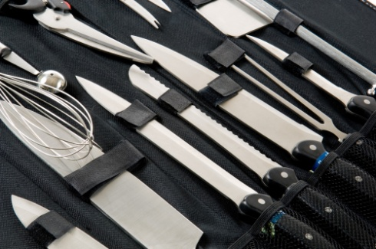
Points to observe when cleaning knives include:
- Wash and dry before use to prevent cross contamination
- Never leave knives in a sink with water in it – the water including the detergent and other items make the knife difficult or impossible to see and presents a hazard
- Never put wooden-handled knives through a dishwasher – this will damage the knife and may make it dangerous to use
- Place clean knives in a wrap protector or toolbox – don’t leave unused knives lying around on prep benches where they can become damaged and also pose a safety risk.

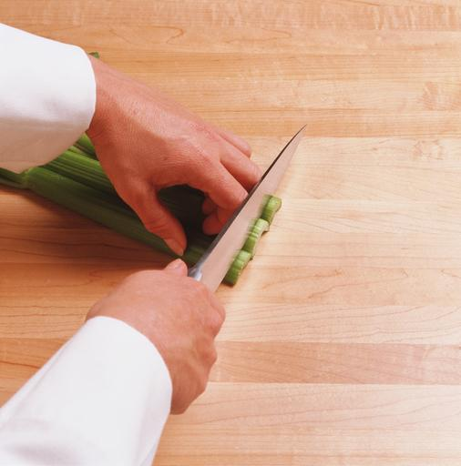
Cutting techniques
Training and supervised practice is needed to gain an appropriate level of skill:
- Hold the knife firmly by the handle
- ‘Tuck in’ fingers holding the food item to present only the knuckles, use knuckles as a guide for the knife
- Keep knife point on chopping board
- Use the right knife for the right job.

Carrying, storage and other protocols
Standard rules include:
- Carry knives with point facing down and close to the body
- Never muck around with knives, including throwing them into a sink or chopping board
- Never run while carrying any knife
- Wash knives carefully paying special attention to cleaning the area where the handle joins the blade
- Wash immediately after use, rinse and dry – hold the knife with blade pointing away from you
- Never test a knife by running a finger down the blade
- Never place a knife under another object or towel
- If a knife falls – let it fall, don’t try to catch it
- Never leave a knife on a bench with the blade facing upwards.

General kitchen safety

Electricity
The following rules apply in kitchens:
- Check electrical equipment before use – bare wires or obvious damage means the item must not be used
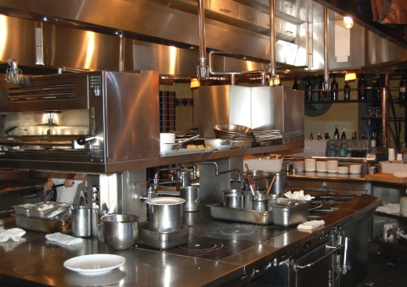
- Never put your hands close to live electricity
- Never put your hands, hair or loose clothing close to the moving parts of any equipment
- Use dry hands to operate electrical equipment – don’t operate electrical items when hands are wet. Water conducts electricity and using wet hands when using electrical equipment can cause electric shocks or electrocution
- Switch off all electrical items after use – it is lazy and potentially dangerous to leave them switched on
- Switch equipment off and pull the power plug out before cleaning it – to prevent the machine starting up while you are cleaning it, or to guard against accidentally knocking an ‘on-off’ switch
- Never use electrical equipment in wet areas, on wet floors or on benches where there is water lying around
- Never, ever place electrical appliances in water.

Checking power and equipment
Employers are required by law to maintain a safe working environment and employees are required to play their part in establishing and maintaining workplace safety.
Periodic safety checks should be conducted by qualified service technicians who follow a standard procedure:
- Use a checklist to ensure all items have been inspected, tested, serviced as required
- Record the date of any service provided to equipment
- Record in writing any faults found with equipment
- Tell management where there is a need for repairs or maintenance
- Record the date of repairs and the name of the repairer
- Report any unsafe or dangerous equipment immediately – the item should be clearly tagged and taken out of service.

Use equipment in accordance with manufacturer’s instructions
There is a need to use equipment in the kitchen according to manufacturer’s instructions. There can be a need to:
- Keep, read and follow any instructions that accompany the delivery of a new piece of equipment. If you can’t find the instructions then ring the manufacturer or supplier to get a copy or check the internet
- Get the manufacturer to come and show you how to use the item of equipment – ask then for some on-site training.
There is an also a need when handling equipment and utensils to do so without causing damage – the user manual will provide advice on this but you should also be guided by the advice given from the supplier.
It should also be remembered failing to follow manufacturer’s instructions in relation to the use, cleaning and maintenance of equipment can void warranties or guarantees.
Finally, check out any individual store practices:
- The place where you work may have some special ways of using equipment or may prohibit a certain piece of equipment being used in a particular way.

Manufacturer’s instructions
Suppliers of quality commercial kitchen equipment will provide training and advice on the safe use and operation of their equipment.
- They want you to get the best out of it, and they want you to buy from them next time you have to make a purchase.
Problems will arise when people try to use machinery that they are unfamiliar with the correct operational procedures.
If instructions are not followed it can cause the machinery to be damaged or cause people to injure themselves or others.

Energy conservation
There are many things you can do every day in the kitchen to conserve energy.
The following points should be considered but always enquire as to what the house rules and establishment ‘Standard Operating Procedures’ are:
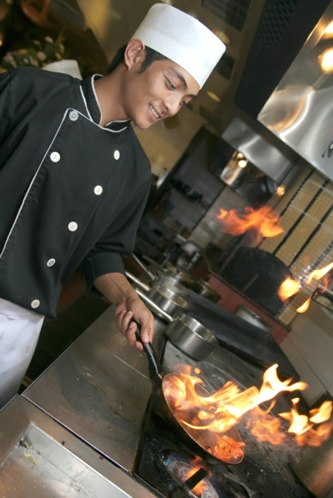
- Turn gas flames off when not being used
- Use the lowest possible gas flame at all times to achieve the required task
- Place lids on pots when you boil water or cook (green vegetables are an exception to this rule)
- Turn off ovens and hot plates when not in use
- Cook food no longer than is necessary
- Preheat ovens only when you need them – don’t leave them on standby all day ‘just in case’
- Check oven doors and oven door seals regularly to guard against heat loss
- Always set the oven to the correct temperature – check the accuracy of the thermostat controls regularly
- Keep oven doors closed to prevent heat loss
- Keep a check on cooking times and temperatures
- Turn off lights whenever they are not required
- Keep refrigerator, freezer and cool room doors closed
- Use automatic timing and switch-off devices on electrical equipment wherever appropriate.

List of possible equipment requirement
Stove; gas or electric | Steamer | Salamander | Pressure cooker
Grill | Oven | Wok | Microwave oven
Food Processor | Slicer | Hot plate | Food warmer
Rotisserie | Mincer | Mixer | Urn

Student Activity
Students need to research the list of equipment and collect data on all pieces and write a report on the following:
Where products can be purchased
Price of equipment
What is required for the equipment to be used within the enterprise
Photograph needs to be supplied in the report.

Individual items
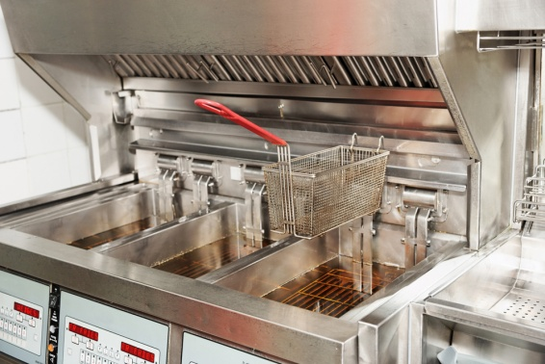
Deep fryers – these require regular straining of the oil used:
- Replace oil when necessary
- Service to the gas pilot light and the thermostat is essential
- Operate the deep fryer at holding temperatures when not in use to conserve energy and to extend the life of the cooking oil or fat.
Bain-maries – whether gas or electric, these require comprehensive cleaning after use:
- Thermostats, gas supply lines and electricity leads/points should be checked regularly and serviced as needed
- If the water supply is automatic check its supply has not been turned off by the last operator and it is open whilst in operation.
Refrigeration – whether fridges, freezers or cool rooms ensure all doors and lids close and seal properly:
- Check the seals on the doors regularly and ensure these are cleaned regularly to help prevent sticking and splitting – these should be replaced where worn or split
- Keep doors closed to allow refrigeration units to operate to their full potential
- Check thermostats regularly and verify readings with an independent thermometer as indicated by your Food Safety Plan
- Keep fridges and coolrooms clean and tidy at all times
- Have motors, compressors serviced regularly and re-gassed as required.

1.2 Identify staff requirements

Introduction
It is a fundamental requirement, in all food establishments, that staff are well presented.
Personal presentation requirements for each outlet will be established by the owner or manager of the store and will be explained during your induction. You are required to comply with them at all times.
Excellent personal presentation is important because the way you look to customers reflects the food you serve.
Customers will infer or think that a staff member who is not well presented will also be unhygienic in the way they prepare, cook and serve the food.
Correct personal presentation meets customer expectations and gives them confidence in the food we sell.

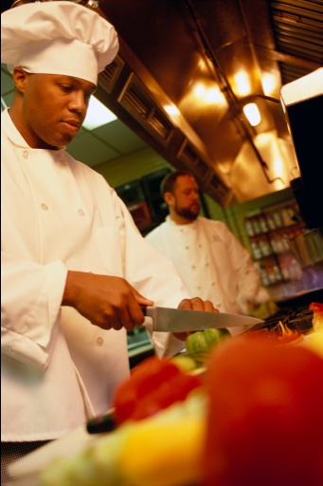
Personal presentation
The basics are:
- Keep your uniform neat, clean and tidy
- Keep uniform in good condition – mend tears and rips; sew buttons back on; fix dropped hems
- Wear the required uniform – at all times, in full
- Have a spare change of clothes available in case your clothing becomes too dirty to wear
- Wash and iron your uniform between each use
- Wear clean clothes for each shift.

Personal hygiene
This section will focus on the need for high levels of personal hygiene as a prerequisite for the correct handling of food items – your Food Safety Plan will provide further detail relevant to your workplace.
This section reinforces content presented in unit ‘Follow workplace hygiene procedures’ (the pre-requisite for this unit).

Follow all personal hygiene requirements – and take it seriously
As with many aspects of control in other areas, all personal hygiene requirements and regulations must be abided by.
Failure to follow just one rule can (and has) led to massive outbreaks of food poisoning causing not only loss of trade and jobs at the venue, but also deaths in the community, especially amongst the very young, the very old, and the very weak.
Personal hygiene is a serious issue and must be treated as such – the industry simply cannot afford to tolerate workers who treat it as a joke.
You are regarded by customers and your employer as a professional and you must therefore know what is expected, cultivate sound work practices, and be vigilant in ensuring requirements are complied with.
An outbreak of food poisoning traced back to you is a very serious matter.
Basic personal hygiene rules are:
- No jewellery to be worn on hands and wrists of food handlers:
- Food can lodge in the jewellery, deteriorate and then fall back into food, whilst in addition there is a chance that gems may fall out into the food providing a physical food contaminant. If you simply must wear a ring, then cover it using a glove or Band-Aid
- Facial hair must be kept neat and controlled:
- Hair should either be covered or sprayed to keep it controlled in such a way that hairs do not fall into food. Long hair must be tied back (this is applicable to waiting staff as well as food preparation and food service staff) and beards should also be covered
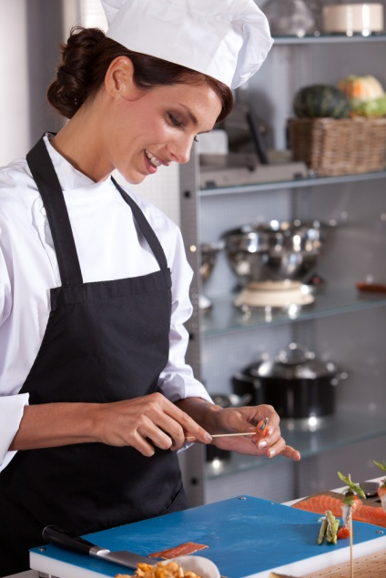
- Fingernails must be short:
- Cracked fingernails and chipped nail polish can harbour bacteria and may flake off into food – this applies even to clear nail polish. Use a nail brush to clean under them to remove bacteria, clean and free of polish
- Clothing must be clean:
- Minimum requirement is for clean clothes for each shift with further changes as spillages and ‘working dirt’ dictate. Food handlers are not permitted to wear food handling clothes to and from work
- Cuts and sores must always be covered:
- A proper, coloured, waterproof dressing must be applied and a finger stall used where necessary
- Food handlers in the acute state of a common cold must not handle food.
Food handlers with any communicable disease must absent themselves from dealing with food until receiving a certificate from a doctor stating that they are cleared to work with food.

Hand washing
World Health Authorities believe the single most important aspect in preventing food poisoning outbreaks is for food handlers to wash their hands as set out by the regulations.
The recommended method of hand washing is to use warm running water (40°C is the recommended temperature):
- A nail brush
- Anti-bacterial liquid soap - bars of soap can pass on bacteria to the next user
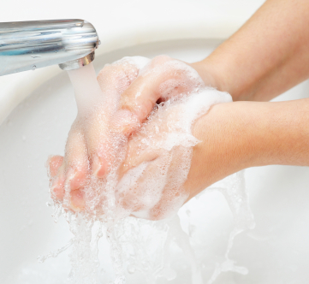
- Air dryer or disposable paper towels for drying.
When washing hands, they should be massaged together for 20 seconds up to and above the wrists, before rinsing.
Most establishments are now fitted with sinks that have taps that can be foot, knee or elbow operated, or that function on an electric-eye sensor to guard against contamination from taps.
The practice of creating a barrier between the food and hands is good policy – this means using tongs or some other implement to handle food, or the wearing of disposable gloves.

Customer skills

What is communication with customers?
Communication with customers is any interaction that carries with it a message; the communication can be intentional, or unintentional.
This means we often send a message to the customer without knowing it. They receive this message – and they may, or may not, know it is an unintended one – and draw a conclusion as a result of it. Hopefully, it is a positive message, but frequently it is not.
It is important you understand you are regularly communicating with customers without knowing it and so must be mindful about:
- What you say
- What you do
- The way you do things
- How you look
- Your speech
- Your gestures.

Elements of communication with our customers
Communication comprises verbal and non-verbal communication.
The biggest concern in the retail area is that staff fail to appreciate the extreme importance of non-verbal communication – for its relevance, influence and role.
The first thing to be aware of is that non-verbal communication is usually the first type of communication that customers encounter.
It starts from the moment they see us: they start making judgements about us, and the store, from what they see us doing.
They start forming opinions about everything to do with the store, including things such as the standard of the service, and the value-for-money of the products.
If they see staff who are working diligently, and who are dressed appropriately, then they get a positive impression of the store.
If they see staff slouching around, mucking about and generally not focusing on what they are supposed to be doing, then they generate a negative impression.
Verbal communication is naturally another readily identifiable and similarly important factor.
This means that whenever you speak, you must also pay attention to:
- What you say
- When you say it
- How you say it
- The words you choose
- The pacing of what you say
- The tone of your voice
- Your volume
- Your use of jargon.
Consistency is also important:
- It is not enough for you to be professional and courteous to customers today, but not tomorrow.
- It is not enough to be polite and welcoming in the morning, but not in the afternoon.
- It is not enough to be civil and hospitable to those you know, but not to those you don’t know.
You have to professional and courteous, at all times – to all customers.

1.3 Plan a menu to meet establishment and client requirements
This unit applies to those working in catering enterprises where fast food or a limited range of food items are prepared and served.
Those undertaking this role work under supervision and usually are part of a team.
The menu will have been designed to meet strict criteria.
Modern themes are:
- Burgers | - Pizza | - Fried Chicken | - Falafel
- Sandwiches | - Hot dogs | - Sushi | - Kebabs
- Noodles | - Soups | - Pies | - Fish and chips
Fast food outlets will vary from country to country. Some will specialise in local foods that can be produced quickly for large customer numbers or they may introduce special cuisine from other cultures and nationalities.
If the fast food outlet has seating for customers to ‘eat in’ then the menu will usually offer value added items such as salads and range of small finger foods.
There may also be parts of the menu that ‘drop off’ due to poor sales and new items that are introduced to ‘pump up’ sales figures.
Before every service session there is a standing need to review the menu to identify what is available for sale and what is ‘off the menu’.
This review should also identify any special menu items which may need to be prepared.
How do you determine what needs to be prepared?

Standard practices include:
- Speak to management and ask what they want prepared
- Check the stock levels in store to identify what needs to be moved
- Check any internal documents identifying specials for the session
- Check orders which may have been placed.
It is also essential to ensure that:
- Any menu items about which there have been complaints are investigated to identify if they can continue to be sold, or if they need to be taken off the menu
- All items to be prepared are safe to eat – verifying ‘use by’ dates, checking all identified food safety protocols for the business (and the individual food item) have been followed
- No products to be used are subject to a food recall.
There are many factors which may influence the menu items to be prepared.
Businesses may vary the menu items they sell based on:
- Weather
- Season
- Local events
- New ingredients which have become available – including the use of raw ingredient and new pre-prepared commercial lines
- Special promotions the store is conducting.
Check with your supervisor to see if any of the above applies.
Requirements of menu for fast food outlets:
- Food must be able to be cooked and served quickly
- Food should be simple
- Food should be able to be produced in minimal space
- Limited selection on menu.

1.4 Plan workflow and production schedules

Introduction
Workflow planning for fast food outlets will depend on how much has to be processed at venue site.
Many successful fast food outlets will purchase product from other manufacturers and cook and assemble at venue site.
Fast food is about quick turn over of stock.
The planning of the menu is critical to how much production skill is needed by staff at the venue site.

Stores and management will allocate nominated tasks and responsibilities to individual staff to ensure all mise-en-place duties are completed before service commences.
Your role is to work efficiently to accomplish the jobs set for you.
If you fall behind required timelines:
- Notify management – so they can make alternative arrangements
- Ask others for help – at a minimum you must notify others you have fallen behind.
You should always be alert to the needs of other staff in this regard and be ready to offer help where you see it is needed without waiting to be asked.

Identifying preparation and handling requirements for food items

Preparing fruit and vegetables
Fruit and vegetables will need to be washed and cleaned, and may have to be trimmed and sliced; your Food Safety Program may also require them to be washed in a sanitising solution.
Special attention to washing and cleaning is important to make sure all contaminants are removed – just because they look clean doesn’t mean they are safe to eat.
General procedures include washing all vegetables thoroughly in cold water.

Peeling and trimming
Use a peeler, chef’s knife or paring knife to remove skin, root ends and blemishes; peel carefully to minimise waste:
- Peelings are the outer parts (skins, tops and tails) which are thrown out
- Trimmings are offcuts from fruit and vegetable and can be used in other cooking dishes such as stocks and sauces.

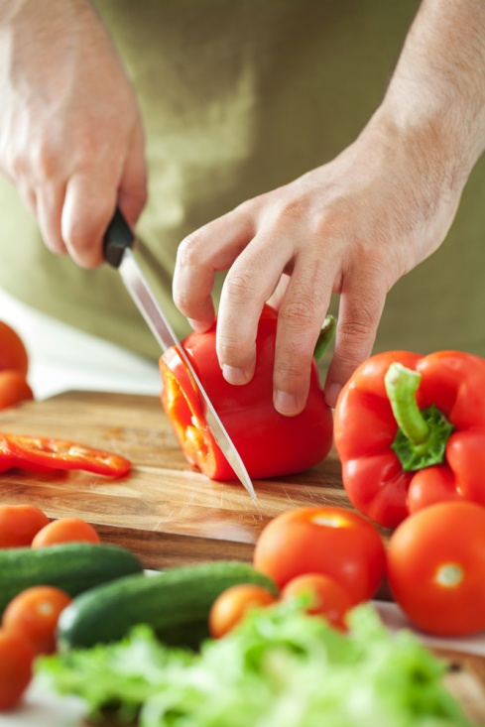
Cutting fruit and vegetables
Common cuts include:
- Slice – bread and onion rings
- Chop – chopped parsley
- Dice – large or medium vegetable cubes
- Shred – lettuce, cabbage.
When chopping and dicing:
- Keep the knife tip on the chopping board while quickly raising and lowering the blade, cutting the product on the down stroke
- Never lift the tip of the knife off the cutting board.
When slicing and shredding, the blade of the knife is passed across the item being cut with a smooth forward motion.
The free hand is used to push the food forwards and govern the cut size.

Preparing general food items

Batters and coatings
Coating food protects the natural flavour of the food, seals in juices and helps to protect the oil. Food must be seasoned prior to coating or applying the batter.
There are two types of coating:
- Wet (batters, flour and egg, flour and milk)
- Dry (breadcrumbs).
All foods fried in batter must be served immediately or appearance, crispness and texture will be lost.
Many different items (meat, fish, shellfish, vegetables, cheeses and ice cream) can be coated and fried.

Standard crumbing procedure
Crumbing must be done in the correct sequence to prevent mess and waste. The procedure is:
- Dry the food
- Season it
- Dip in flour and coat evenly – shake off excess
- Dip completely in egg wash – allows excess to drain off
- Dip in breadcrumbs, gently pressing them on – shake off excess
- Fry immediately, or store for later use.
Try to keep one hand dry during the above procedure and work sequentially from left to right.

Salads and sandwiches
Salads provide variety to the menu, cater for the trend to healthy eating and add contrast of texture and colour to the menu.
Salads (usually) are cold and prepared from raw, cooked or blanched vegetables, served singly or in combination. Warm salads are also popular.
Fresh herbs, fruits, nuts, pasta, seafood, meats, cheeses and cooked eggs may be added with a range of sauces and garnishes.
Recommended storage temperature for salad vegetables is 7°C-10°C.
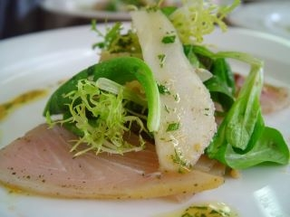
When making a salad:
- Use fresh, quality ingredients = because they will be served in their original state
- Ensure it has eye appeal
- Ensure flavours are compatible
- Avoid elaborate garnishes.

Salad dressings
Dressings help to hold the salad ingredients together, add taste and lubricate the item. Two common salad dressings are:
- Vinaigrette – also known as French Dressing (mixture of oil, vinegar, salt and pepper)
- Mayonnaise.
Many fast food outlets use proprietary salad dressings rather than making their own.

Salad preparation
Salads are usually displayed in glass, china or wooden bowls, or in bain-marie trays. Points to note include:
- All ingredients should be fresh and high quality
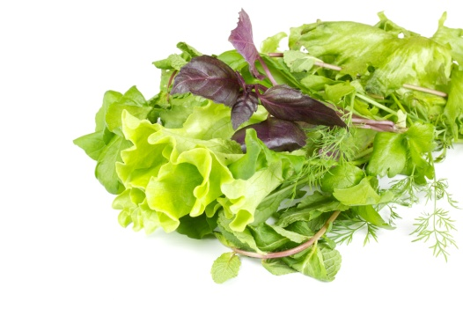
- Trim, wash, drain and dry leaf vegetables
- Remove any unattractive bits
- Tear (rather then cut) large salad leaves to aid presentation and reduce browning
- Cut other ingredients evenly and neatly
- Cover with plastic wrap, a damp cloth or paper towelling
- Refrigerate until needed
- Dress and mix, where possible, immediately before service – avoid adding salad in advance as it makes the salad less presentable and less appealing.

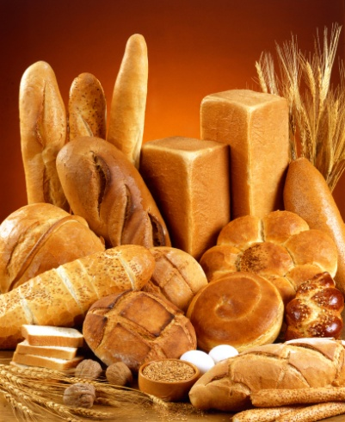
Sandwiches and rolls
Butter and margarine are used in sandwiches and rolls to:
- Add flavour
- Prevent the bread from absorbing moisture from the filling
- Help ensure the filling and bread stick firmly together.

Fillings
Fillings can include sliced meats, vegetables, eggs and cheese, spreads and cold sauces. Tips to assist in producing sandwiches and rolls that will be a hit with customers include:
- Prepare fresh supplies of fillings each day (or each session)
- Prepare tomatoes, cheese, lettuce and meats in advance – slice uniformly
- Dry lettuce thoroughly
- Criss-cross sliced ingredients (cheese and meat) when preparing them for use in sandwiches and rolls – it makes them easier to pick up
- Use separate utensils for each filling to prevent flavour and colour transfer.
Sandwiches may be pre-prepared to a number of traditional combinations (ham and tomato; chicken and salad; cheese and tomato; tuna and onion) or prepared to suit individual orders and tastes.
Fillings may include smoked salmon, ham, turkey (plain and smoked), roast beef, various smallgoods, seafood, cheeses or boiled eggs.
Garnishes on sandwiches, rolls or platters may include shredded lettuce, tomato wedges, cucumber slices, carrot curls, fruit slices, spring onions, carved radishes, sliced gherkins, olives, pickles, chutney or herbs.

Slicing and cutting products

Vegetable cuts
Vegetables can be cut into many shapes – or cooked whole.
Accuracy in cutting the food is very important – whilst we don’t expect them all to be exactly the same they must be very close to the measurements given below.
Uniformity of cuts provides a more eye-appealing product, and – equally as important – means the food items will cook evenly.
Traditional vegetable cuts (note these cuts may also be applied to other foods too, but are more commonly referred to as ‘vegetable cuts’) are as follows:
Julienne – strips such as carrots but can include ham) of 3mm x 3mm x 40mm long. Method is:
- Top, tail and peel the carrot
- Cut into lengths of 40mm
- Square the sides
- Slice into strips 3mm thick – lay strips flat and cut lengthwise to obtain matchstick-shape strips.
Brunoise – small cubes of 3mm x 3mm x 3mm. Method is:
- Cut the vegetable into julienne
- Stack julienne strips into piles and cut through at 3mm intervals.
Paysanne – thinly sliced triangular, round or square shapes. The round shapes to be 15mm in diameter, squares and triangles of 5-10mm thickness with 15mm width.
Macedoine – vegetables cubes of 8mm x 8mm x 8mm.
Jardiniere – small batons similar to julienne of 4mm x 4mm x 20mm.

Potato cuts
There are many ways to slice potatoes, especially for deep frying:
- (pommes frites) – 60mm x 10mm
- Chips (pommes frites) – 1mm thin, round slices
- Wafer potatoes (gaufrettes) – thin slices in a trellis pattern
- Matchstick potatoes (allumettes) – 50mm x 5mm
- Straw potatoes (pailles) – fine strips 50mm x 1mm.
Modern preparations of these will come from the factories pre-cut, blanched and frozen.

1.5 Prepare standard recipes for menu items

Introduction
Standard recipes are employed to reproduce a product to consistent look and taste.

The standard recipe
Standard recipes form the basis of the food control system.
The purpose of a standard recipe is to standardise the production of each food item on a menu so food will be consistent in terms of quality, quantity and cost.
The main reasons for using standard recipes are to:
- Maintain a consistent quality
- Record the food cost for each menu item
- Control the portion size
- Establish the food cost percentage for each menu item
- Assist with producing accurate food orders
- Assist in the training of new staff.
Advantages of using standard recipes include benefits to staff, customers and the operation, such as:
- They are a form of communication from management to staff ensuring the required standard in food production is maintained regardless of who is responsible
- Ensuring the food produced by anyone at anytime is consistent thereby building customer confidence in your establishment
- Avoiding unnecessary costs enabling all menu items to be produced within nominated guidelines and quality standards.
New recipes should be tested and calculated correctly before they are recorded onto standard recipe cards since the recipe card forms the basis of the food control system for the establishment.

Standard recipe cards
All the information needed to operate a standard recipe is recorded on a standard recipe card.
A standard recipe card should contain the following details:
- Name of the menu item
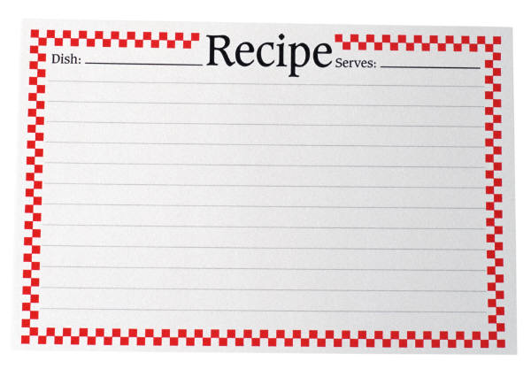
- Section on the menu – where applicable
- Recipe number
- Date costed
- Portion size
- Portion yield
- Portion cost
- Food cost percentage
- Selling price
- Ingredients – listed in order of usage
- Quantity of ingredients
- Unit of ingredients – units of measurement for ingredients
- Unit cost – using invoices as source documents for this
- Total ingredient cost
- Total cost of item
- Production method in the correct sequence
- Photograph of finished product.
Note: The use of standard recipe cards may not be wide-spread in all fast food outlets (especially smaller owner-operated businesses) but their use has a lot to offer.

Example of a standard recipe card
Item |  | Oyster Mornay |  |  |  | Portion Size |  | 1 doz
Section |  | Entrée |  |  |  | Portion Yield |  | 1
Recipe No. |  | 12 |  |  |  | Portion Cost |  | $6.51
Date Costed |  | 09/06/2010 |  |  |  | Food Cost |  | 32.2%
Selling Price |  |  |  |  |  | $20.20
Ingredient | Qty |  | Unit | Cost unit | Cost total |  | Method
Oysters | 1 |  | doz | 6.20 | 6.20 |  | Remove oysters from shell and poach until cooked.
Parmesan cheese | 0.03 |  | kg | 4.80 | 0.14 |  | Wash shell and place on rock salt, opening facing upward.
Parsley | 1 |  | sprig | – | 0.01 |  | Place oyster inside, sprinkle with cheese and gratinate under salamander.
Mornay sauce | 0.1 |  | lt | 1.60 | 0.16 |  | Decorate with washed sprig of parsley and serve immediately.
Total Cost |  |  |  |  | $6.51

Choosing correct ingredients
Whether standard recipes are used or not, the success and timing of food service can be attributed to correct preparation.

This begins with planning that includes:
- Ordering the correct ingredients
- Ordering the correct quantities of ingredients
- Carrying sufficient stock on-hand to meet demands
- Selecting the correct recipe
- Correctly interpreting the ingredients so the correct ones are used
- Correctly weighing and measuring ingredients
- Choosing and preparing the correct equipment.
The amount of ingredients purchased depends on demand and turnover – customer expectations, staff abilities, advertising that has been undertaken, equipment available, storage space, available cash are all factors.

Work Projects
It is a requirement of this Unit you complete Work Projects as advised by your Trainer.
You must submit documentation, suitable evidence or other relevant proof of completion of the project to your Trainer by the date agreed.
Student have to decide on the style of fast food outlet. Keep the choice simple.
When students have decided on the theme then the following criteria can be met.
1.1 Identify required equipment:
- Equipment for staff service area
- Equipment for kitchen area
- The kitchen area can be the service area.
- It is quiet common for the service area to be an extension of the kitchen.
1.2. Determine staffing requirements:
- How long will the business be trading
- How many cooking staff
- How many service staff
- Who is going to clean
- Who is going to clear tables
- Staff can be required to be multi-skilled.
1.3. Plan menu requirements:
- Choose a theme; Burger? Chicken?
- Allow for different flavour combination to give variety
- Remember: chicken is chicken; make it interesting
- Remember to develop drinks and refreshments to complement dishes being served.
1.4. Plan workflow for production:
- Develop plans for production or assembly of products after they have been received into enterprise control
- Nominate who is going to be responsible for each task
- Give nominal timeframe for these tasks.
1.5 Prepare standard recipes for menu items.
- Each menu item will need a standard recipe
- Each standard recipe will have to have all ingredients and consumables required
- Consumables are items such as serviettes, sauces, toothpicks or drinking straws.

Summary

Plan for fast food production
Identify large and small equipment requirements for menu and volume
Large equipment will be in place and difficult to move
Small equipment will be a varying quality
The choice of equipment will be determined by the style of food
Care needs to be taken when purchasing equipment, if it is decided that the product that the machine is to be used for does not sell well then the machine becomes redundant.
Identify staff requirements
Good customer skills
Good personal presentation
Good hygiene skills.
Plan a menu to meet establishment and client requirements
The larger the menu the more difficult it will be to be fast food
Keep selection to a them; such as burgers or Mexican taco
Customers want fast service; good quality food for money paid.
Plan workflow and production schedules
Workflow planning is about what can be produced in house and what can be purchased from reputable supplier
Fast food can be produced off site from various manufactures and brought to a central venue and assembled.
Prepare standard recipes for menu items
Standard recipes must include all ingredients and consumable required to complete the sale of the menu item
They need to include instruction on how the product needs to be assembled
Photographs assist in explaining how what the product should look like when completed
Copy in office should include costing of ingredients and sales price.

Element 2:
Prepare, cook and hold items for fast food outlet

2.1 Use appropriate preparation and cooking methods

Introduction
Appropriate cooking methods must be applied to produce the required methods items, meet customer expectations and ensure the safety and appearance of the food.
There are many generic practices you need to become competent in which are regularly applied when preparing fast food.
Modern fast food outlets will have minimum cooking required.
Ovens; multipurpose that will bake roast or steam as required for heating food to required temperature.
Deep fryers that give the characteristic texture and flavour to foods that is not achievable with other cooking methods.
Grilling for cooking short order meats like chicken breasts or strips, beef burgers and fish as required.

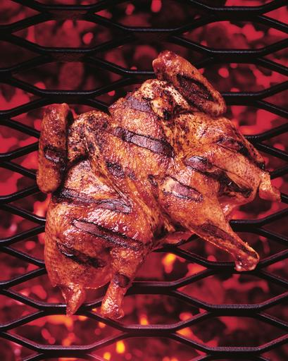
For grilling
When grilling, remember the following:
- Choose only small items
- Choose the best quality, tender foods
- Brush the food with oil and season prior to grilling. Fish must be seasoned, floured and oiled to prevent burnt particles from affecting the food and to allow the food to seal immediately
- Grill plates and grill bars must be spotlessly clean and lightly oiled to prevent food sticking, to prevent burnt particles from affecting the food and to allow the food to seal immediately
- Heat must be fierce to allow food to seal and colour instantly – once the food has been sealed, the heat can be reduced
- Use tongs rather than forks to turn the food – forks will pierce the food and allow juices to escape.
Grilled food should not be finished off in the oven because this will change the cookery principle to roasting and the texture and flavour of the food will not be typical of grilled food.

Trellising
Trellising refers to the marking of meat by searing or cutting a trellis, or lattice, pattern on to the surface.
The purpose is to improve the food’s appearance, and sometimes it can assist in the cooking.
Trellising can be done by:
- Marking the meat with the grill bars and then turning it 90º and marking again
- Marking a floured fish with a hot skewer prior to grilling
Trellising is not only done on grilled foods.
A criss-cross of pastry on top of the filling in a flan or tart is an example of trellising as is the scoring of a leg of pork to produce crackling and the marking of the sugar on a crêpe with a hot skewer.

Suitable foods for grilling
Any meat that is grilled should be of the right size (not too large), tender and trimmed of unwanted fat, bones and sinews.
Any fruit or vegetable that is grilled should be cut evenly to ensure even cooking. Fish should be scaled and the fins removed before grilling.
It may be necessary to skin the fish as well.
Foods suitable for grilling under a salamander (broiling) include:
- Whole, small round fish, flat fish and fillets
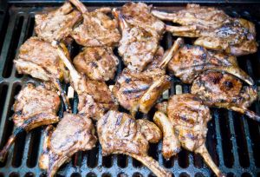
- Ham and bacon slices
- Tomatoes and pineapple rings.
Foods suitable for grilling on grill plates or bars include:
- Pork cutlets and medallions
- Lamb chops
- Beef sirloin steaks, T-bones and beef tournedos
- Baby chicken
- Whole, small round fish, flat fish and fillets
- Ham steaks.

Accompaniments for grilled foods
There are numerous accompaniments for grills which include compound butters, sauces and fruits. Compound or flavoured butters can be made using different flavourings.
The most common and versatile compound butter is parsley butter (beurre maître d’hotel).
Sauces can be served with grilled food. Brown sauces accompany red meats and white sauces are best for fish.
Warm emulsion sauces are also suitable for grills. Fruits and fruit compotes can accompany grilled foods.
Grilled pineapple with ham steaks, grilled tomatoes with grilled lamb, grilled apple or apple compote with grilled pork are recommended.
Grilled accompaniments aid the digestion of fatty foods and clean the palate.

Testing for doneness
Customers expect grilled food to be cooked to their liking so it is important to know how to test for doneness. Methods which can be used are:
- Timing accurately – taking into account the thickness of the food and the temperature used
- Piercing the thickest part with a needle – if the juices are clear, the food is cooked
- The ‘touch and squeeze’ method which requires experience to perfect
- Measuring the internal temperature.
Testing for doneness is a matter of experience. There are culinary terms which identify the degree of doneness for grills.
These are the same as the terms used to describe the degree of doneness of roasted meats (see above).
Utensils and equipment – grilling.
There is a range of grilling equipment available including:
- Charglo griller – gas fired, with hot rock and grill bars
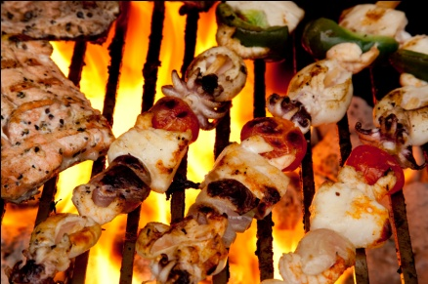
- Grill plates – gas or electric, flat or corrugated, side grill plate
- Charcoal grill – charcoal under grill bars
- Infra-red or contact grill – double-sided electric grill with top and bottom elements, plates flat or corrugated
- Salamander – overhead grill, gas or electric
- Portable corrugated grills – placed on gas rings
- Barbecue kettles – grill bars, fired with charcoal or gas.

Deep frying
Deep frying is the principle of cookery where food is cooked by total immersion in hot fat or oil.
This method is best suited to foods which can be cooked quickly. Most foods need to be coated before deep frying to seal in the juices.
The temperature for deep frying is between 145ºC and 195ºC.
The oil or fat is ready for cooking when a light haze rises from the surface. An easy way for you to tell if the fat is hot enough is to place a crust of bread in it for a few seconds.
If the bread turns a light golden brown colour almost immediately, the fat is hot enough for deep frying. If the crust of the bread goes dark, the frying medium is too hot and you must allow it to cool to the correct temperature before you begin to cook.
The optimum temperature range for deep frying most foods is between 177ºC and 195ºC.
For deep frying:
- Season the food before coating
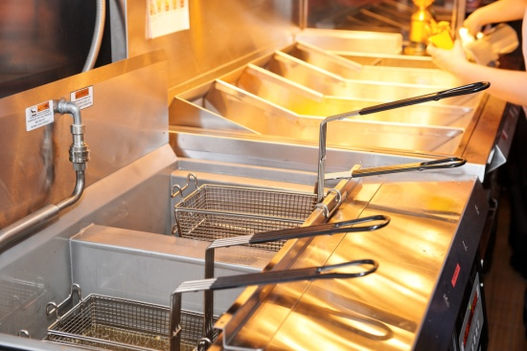
- Shake or drain off excess coating before frying
- There must be a sufficient level of fat in the pan – half or two-thirds full is usually adequate
- The temperature must be hot enough to seal the food as soon as it is put into the fat.
- This will prevent the food absorbing the fat and will help retain the natural juices and flavour
- If the fat temperature is too high, excessive colouring can occur and the final product may not be cooked through
- Keep a spider and a frying basket on hand as a safety measure
- If too much food is put into the deep fryer at once, it may overflow, or the temperature of the fat will drop so much that the food will absorb fat, lose its juices, and the coating may break up
- Using a basket, carefully lower the food into the fat
- Drain the food well on absorbent paper after frying
- Turn the deep fryer down to a holding or stand-by temperature of 90ºC-100ºC between uses
- Allow the fat to recover heat before adding the next batch of food
- Strain the fat after every service, because remaining food particles may break down the frying medium or burn and contaminate the fresh product.

2.2 Use appropriate equipment

Introduction
Appropriate cooking methods must be applied to produce the required methods items, meet customer expectations and ensure the safety and appearance of the food.
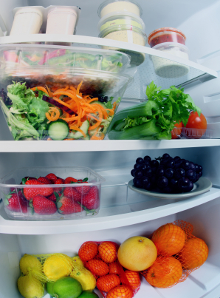
There are many generic practices you need to become competent in which are regularly applied when preparing fast food.

Defrosting items
On many occasions items need to be thawed (de-frosted) before use.
When thawing or defrosting items:
- This should take place in a refrigerator rather than on a bench:
- This is the preferred and recommended way of defrosting frozen food. Large pieces of meat may take 2-3 days, so planning ahead is vital – this enables the item to remain outside the Temperature Danger Zone for the entire time it is thawing
- If pressed for time, use a microwave to defrost, moving pieces of food during the procedure – use or cook immediately, as the microwave will have raised the temperature into the Temperature Danger Zone
- Run the item under cold water (less than 20°C) – note it is not acceptable to simply place the frozen item into a container of water and leave it there – the requirement is to place it under running cold water.
Meat and fish should be cooked immediately after thawing. Only defrost the amount needed.

Principles of cookery
The principles of cookery are the foundation of all cooking. A principle of cookery is the definition given to a cooking process that is individual and unique.
Certain principles of cookery are more prevalent in fast food operations than in traditional kitchens however there is always the possibility any principle can be used anywhere.
All cooking of food can therefore be classified according to one of the principles of cookery.
These principles may be used in their own right or can be combined.
All types of cuisine use these principles to some extent so it doesn’t matter if you are cooking Italian, Indian, Chinese or French.
All foods consist of atoms and molecules which are always moving. When heat is applied this motion is accelerated and friction is greatly increased and friction creates heat.
Heat transfer within food usually occurs by conduction but this is not always the case, especially where the food is a liquid.
In this case, heat transfer is chiefly by convection. When food is roasted, baked or grilled, the heat transfer is by radiation.

What is conduction?
Conduction is the passage of heat through a solid, or from one solid to another, provided they are in contact (such as a saucepan on a hot plate). Metals are good conductors of heat.
Cork, plastic, china, wood, string and cotton are bad conductors of heat, so that is why they are used for articles which need to be kept cool (such as oven gloves).

What is convection?
Convection is the passage of heat through liquids and gases. For example, when water is heating in a saucepan, the water at the bottom is heated first. It rises to the top because it is lighter and the heavier cold water takes it place at the bottom of the pan.

What is radiation?
Radiation is the passage of heat in straight rays from a hot object. Any object in the path of the rays becomes hot (such as gas and electric grills).

Manufacturer’s instructions
Suppliers of quality commercial kitchen equipment will provide training and advice on the safe use and operation of their equipment:
- They want you to get the best out of it
- They want you to buy from them next time you have to make a purchase.
The following section is based on information supplied by Hobart Food Equipment.
This information is an indication of the information readily available and what you need to become familiar with.
Ask your supplier for a ‘Use and Applications Handbook’ (or similar).
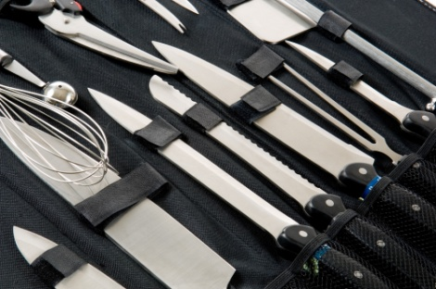
Hobart manufactures a ‘CombiCutter’ which is a combined vegetable preparation machine and vertical cutter/mixer.
Without training, advice or the proper knowledge, kitchen staff may be unable to fully use the capabilities of this unit, which are as follows:
- Vertical cutter/mixer knife – chops and grinds meat, fish, fruit, vegetables, and nuts. Also blends sauces, aromatic butter, mayonnaise, soups, dressings, thickenings, desserts, etc
- Standard slicer 10mm – slices firm products such as root vegetables, and dices root vegetables, fruit, potatoes, cabbage, swedes, carrots, cucumbers, tomatoes, apples, etc
- Crimping slicer 4.5mm – ripple slicing of beetroot, cucumber, carrots, etc
- Fine cut slicer 1, 2, 4, 6mm – slices root vegetables, leek, onion and cucumber, whilst different size slicers will slice bell peppers, shred lettuce and cabbage, and flake parmesan
- Julienne cutter – will provide julienne strips for soups and salads
- Raw food grater – will grate carrots and cabbage for raw salad, as well as grate nuts and dry bread
- Fine grater – will grate raw potatoes for potato pancakes, grate hard/dry cheese and dry bread.
The point to all this being you need professional advice on how to use kitchen equipment so you get the most out of it.
The “Hobart” equipment manufacturing company even offers an ‘Instructional Video’ to help you get the most out of Automatic slicers.
Finally, most operation manuals will usually have daily and weekly cleaning regimes, replacement advice for certain parts (showing how to replace doors, light globes, etc), service and parts information, and a comprehensive troubleshooting guide.

2.3 Follow food safety requirements

Introduction

Food safety requirements for potentially hazardous foods
Many fast foods are prepared from potentially hazardous ingredients.
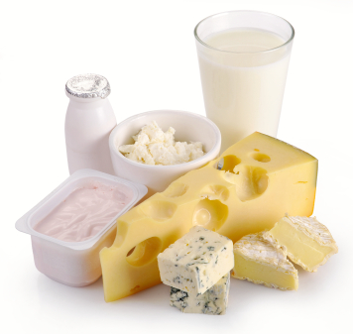
The list of these foods is really without end, but focuses on high protein foods.
Pay special attention to:
- Milk and milk products, soft cheeses – butter, yoghurt, custards, cream cakes, cheese, baked custard tarts and dips
- Egg products – quiche, fresh pasta, duck and game bird eggs
- Meat and poultry – all cuts; cooked and un-cooked
- Smallgoods products – ham, pressed chicken but note salami is not a high risk food
Processed meat products including chicken – pâté, meat pies, sausages, sausage rolls, coagulated blood, rissoles, meat balls:
- Fish, shellfish, fish products, fish soups and fish stocks – caviar, fish balls, patties, salads, sauces and stews
- Other food dishes that contain any of the above ingredients – pizza, prepared meals, sandwiches, salads and rice.
If you are ever in any doubt about whether or not a food you are dealing with is a high risk food – ask your local Environmental Health Officer with Local Government Authority.

Cross-contamination
Cross-contamination occurs when micro-organisms are transferred from contaminated food preparation areas and foods to other foods.
Cross-contamination can occur from cooked to cooked foods, and from raw to raw foods, but most often occurs from raw to cooked foods.
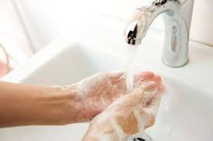
Bacteria are hitch-hikers – they cannot fly from place to place – they hitch a lift in order to get from place to place.
Their destination from our food safety perspective is food, and the means of transport they use to get there can be our hands, a cloth, a utensil, or a drop of blood.
The bacteria can be transferred (i.e., hitch-hike) from the toilet to our hands and from our hands to the sandwich we are making.
They can travel from spilt stew to the cloth we used to wipe up, and then on to a clean plate that is later wiped with the same cloth prior to having food placed on it.
They can travel in a drop of blood that drips from a slice of raw meat onto prepared dishes stored below in the refrigerator.
Harmful bacteria can be present in raw food or they can be transported to both raw and cooked foods by careless handling such as slicing raw and cooked meat with the same knife or slicer without cleaning in between: this is called ‘Cross-Contamination’.
Even small numbers of bacteria are dangerous because they can multiply so rapidly when the conditions are right: moisture, food, temperature, air and sufficient time.
Cross-contamination from raw to cooked food can occur as a result of chopping or preparing raw meat on a chopping board and then using the board – and/or the knife – for chopping and preparing cooked meat without sanitising in between.

Safe food handling practices
Food businesses must ensure:
- Only safe and suitable food is used – purchased from reputable suppliers, and stored correctly
- Food is protected from contamination – via suitable storage and time-temperature controls
- Bacteria are reduced to safe levels – cooking food, sanitising equipment
- Minimising contamination from food handlers – relating to adequate and appropriate knowledge and training, and implementation of personal hygiene protocols
- Keeping different batches of food separate – to prevent cross-contamination from one batch to another.

4-hour/2-hour rule
Food poisoning bacteria grow most rapidly in the temperature range of 5ºC – 60ºC: this range is called the.

‘Temperature Danger Zone’
When high risk food spends time inside that 5ºC–60ºC range, it becomes more liable to cause food poisoning problems and ‘Safe Food Australia’ have provided the following guidelines in relation to time and temperature:
“Any ready-to-eat potentially hazardous food, if it has been at temperatures between 5ºC and 60ºC:
- For a total of less than 2 hours, must be refrigerated or used immediately
- For a total of longer than 2 hours but less than 4 hours, must be used immediately or
- For a total of 4 hours or longer, must be thrown out.”

Cooking temperatures
The requirements of approved standard recipes must be followed as they will contain safe food handling
Practices, temperatures and times.
It is a general requirement all foods are cooked ‘thoroughly’.
‘Safe Food Australia’ offers:
“A food business cooks chickens. The business needs to determine how long the chickens need to cook at a particular temperature to ensure they are thoroughly cooked. A chicken is sufficiently cooked when its internal temperature has reached at least 74°C or when the juices of the chicken run clear when the chicken is pierced between the breast and the leg.”

2.4 Hold menu items

Introduction

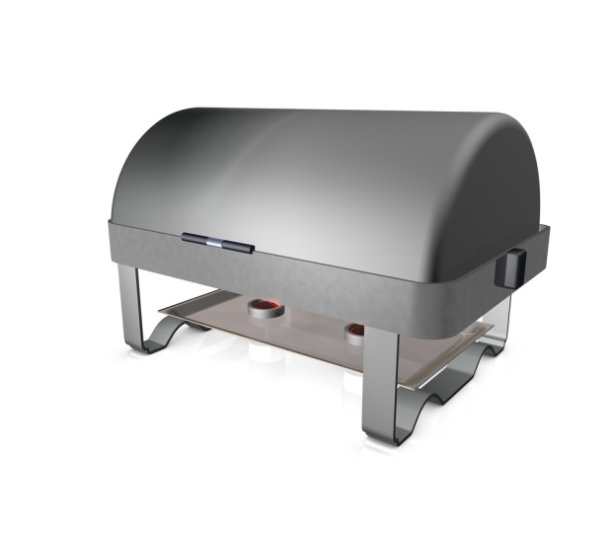
Holding menu items
Holding as a term means to suspend or keep the food in a state at which the enterprise is prepared to sell the food to the consumer.
It relates to the temperature of the food:
- Cold
- Hot
- Room temperature.
When fast food has been prepared/cooked it needs to either be displayed for sale or stored for later use.
This section presents information on safe food holding.

The context
Presentation of fast food items requires placement of menu items in display units in determined locations as required.
The fast food items may be cooked-to-order items that are being held for a short period while the sale is finalised – that is, for the short time when customers select additional items, choose drinks and finalise their purchase.
Other fast food items may be cooked in advance and prepared in anticipation someone will buy them.
The display units may be either hot or cold – some units are able to be used as both, depending on requirements at the time.

Hot holding
Hot display units – also known as ‘hot holding units’ – include:
- Bain-maries
- Pie warmers
- Soup tureens
- Heaters
- Ovens
- Rotisseries.
The temperature of these devices must be such that it holds any potentially hazardous food at a minimum of 60°C.
Standard practice for using these items include turning it on to a high setting to preheat it before the hot food is added:
- Never use the bain-marie to heat the food.
These units are designed only as holding devices not heating devices so the food must be heated before it goes into the preheated unit.
Check your Food Safety Plan to see what recording requirements of this temperature are required by your store, and what your responsibilities (if any) are in relation to this.

Cold holding
Cold display units – also known as ‘cold holding units’ – include:
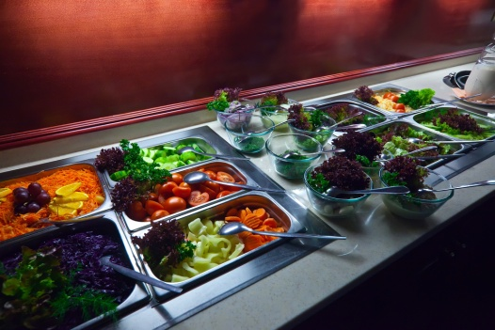
- Refrigerated salad wells
- Refrigerated and glass-fronted display units and cabinets including free-standing refrigerated units and self-contained refrigerated units.
The temperature of these devices must be such that it holds any potentially hazardous food below 5°C.
This unit too should be turned on in advance to allow it to pre-cool/pre-chill.
Check your Food Safety Plan to see what recording requirements of this temperature are required by your store, and what your responsibilities (if any) are in relation to this.

Protection of the food
All food put on display must be protected from contamination.
This will require, depending on the nature of the food item, items are:
- Individually wrapped
- Protected by glass and sliding doors
- Protected by lids on trays.
Note: raw fruit and vegetables may be displayed, for example, in a bowl on a counter without being wrapped or covered if it has not been cut.
Previous notes relating to the 2-hour/4-hour rule also apply here.

2.5 Reheat menu items

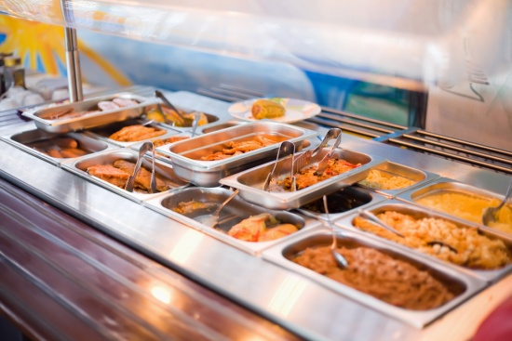
Introduction
Reheating previously cooked foods is perfectly legal.
This means foods can be prepared in advance for later use, and foods not sold yesterday can be reheated and sold tomorrow.
Specific requirements apply to the reheating of foods to ensure food safety and quality.

Reheating requirements
Any foods that has been cooked and not served to customers can be cooled following the 2 hour 4 hour rule.
“A food business must, when cooling cooked potentially hazardous food, cool the food:
(a) Within 2 hours – from 60°C to 21°C; or ambient room temperature
(b) Within a further 4 hours – from 21°C to 5°C.”
Part (a) is conducted out of the coolroom and part (b) is conducted in the coolroom.
If the food has been cooled correctly then it can be reheated and sold to the public.
Foods may be reheated in a microwave oven, conventional oven or fan-forced convection oven, or by using a pot, steamer or other piece of equipment.
The important food safety considerations are the times and temperatures, whilst your store may have additional considerations such as quality, visual appearance, shrinkage and waste.
Foods can be reheated once only – if the food is reheated and not sold/used, it must be thrown out. It cannot be reheated again.
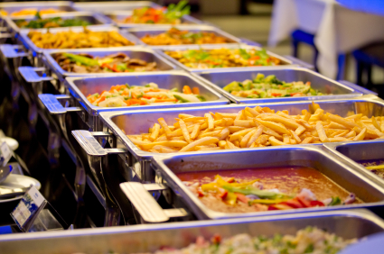
“A food business must, when reheating previously cooked and cooled potentially hazardous food to hold it hot, use a heat process that rapidly heats the food to a temperature of 60°C or above, unless the food business demonstrates that the heating process used will not adversely affect the microbiological safety of the food.
This requirement only applies to potentially hazardous food that is to be held hot, for example in a bain-marie.
It does not apply to food that is being heated for immediate consumption. This food can be heated to any temperature as it is not being heated for holding hot.
Potentially hazardous food that has been previously cooked and cooled and is to be held hot must be heated rapidly to a temperature of 60ºC or above.
This is to minimise the amount of time that the food is at temperatures that allow food-borne pathogens to grow during the heating process.
Pathogenic bacteria may be present in cooked food from spores that survive the cooking process and vegetative (live) cells that have been able to survive the cooking process due to undercooking, as well as from contamination that occurs after cooking.
These pathogens can grow while the food is being cooled and some may also grow during cold storage.
‘Rapidly’ has not been defined but the time taken to heat all the food to 60ºC should not exceed 2 hours.
A food business may use an alternative heating process if the business can demonstrate that the alternative process does not compromise the microbiological safety of the food.
Food businesses are not required to heat potentially hazardous food that has been previously cooked and cooled to temperatures higher than 60ºC.
Food businesses may be advised to heat food to at least 70ºC for at least 2 minutes.”
Any hot potentially hazardous food – reheated or freshly cooked – must be held (in bain-marie, pie warmer, or other display unit) after it has been reheated, at 60ºC or above.
When reheating food all care must be taken not to adversely affect the biological safety of the food.
Check with Local Food Safety Authorities regarding standards expected within your establishment.
What is the standard set out in your Food Safety Plan.
Reheat only what is required because any leftover food cannot be saved for later use.
It must be discarded.

Work Projects
It is a requirement of this Unit you complete Work Projects as advised by your Trainer.
You must submit documentation, suitable evidence or other relevant proof of completion of the project to your Trainer by the date agreed.
Student have to decide on the style of fast food outlet. Keep the choice simple.
When students have decided on the theme then the following criteria can be met.
2.1 How is the food going to be cooked?
- Deep fried, grilled, steamed
- The style of food will determine how the food will need to be cooked
- It can be a combination of several cooking styles
- The more styles of cooking used the more staff required.
2.2. What equipment will be required?
- Develop a list of equipment required.
2.3. Food safety requirements:
- A Food Safety Plan will need to be followed
- Students will have to have a simple Food Safety Plan in place to go with the fast food outlet assignment.
2.4. How will the menu items be held?
- Write a Standard Operating Procedure (SOP) regarding how food items will be held after being cooked so that when the customers receive the food it will still be in premium condition.
2.5 Reheating menu items:
- Write a SOP for the reheating of foods
- This will be included in the Food Safety Plan that has been developed for the outlet
- The SOP in Food Safety Plan must be referenced for this unit.

Summary

Prepare, cook and hold items for fast food outlet
Use appropriate preparation and cooking methods
When producing foods for fast food outlets staff need to use methods that will produce product as efficiently as possible.
Use appropriate equipment
Equipment needs to be fitted that will complete the task quickly
It is difficult to grate 50 kg of carrot on hand grater
If the equipment is not sufficient then the staff will become unproductive.
Follow food safety requirements
All food outlets need to have a Food Safety Plan. Requirements of the plan will be decided by the Local Health Authorities or the enterprise can use world’s best practice.
Hold menu items
Foods need to be held at the correct temperature that will not allow for the growth of potentially dangerous bacteria.
Reheat menu items
Foods need to be re-heated as quickly as possible allow for the food to be in danger zone for minimum time:
Danger zone is between 5°C and 60°C
Foods need to be re-heated to above 70°C.

Element 3:
Provide fast food service

3.1 Serve and present food items in line with customer volume

Introduction
When serving fast food there is a need to meet customer requirements in terms of:
- Speed of service
- Quantity – serve size
- Quality – of facilities, food and service
- Additions – options to add to individualise the food
- Modifications to standard recipes
- Special requirements.


Speed of service
Simply by virtue of its name there is an expectation that fast food is ‘fast’.
Every endeavour should be made to serve customers quickly in-keeping with high levels of customer service.
The point to note is that speed of service must never sacrifice high levels of customer service.
It doesn’t matter how busy you are, there is never an excuse not to be polite and never an excuse to be abrupt or off-hand in the way you serve the paying public.
Where customers have had to wait to be served, or there is an expected delay in the service of what they have ordered:
- Apologise for their wait/the delay
- Tell them of the delay
- Advise them – realistically – of how long the delay is expected to be
- By sympathetic to their situation.
It is a golden rule of customer service that service staff must never reduce service standards to achieve the required speed of service.

Quantity
Most customers will tell you what amount they wish to order:
- Make sure you pay attention to their order to get it right and make it a standard procedure to repeat their order back to them.
This saves serving an incorrect amount (over or under what was required) and often results in the customer adding something to their initial order.
If there will be a delay in serving them because they have ordered a large quantity or their order has to be specially prepared:
- It is best to advise them of this anticipated delay as early as possible so they can decide whether to wait or to change their mind.
Where a large order attracts a quantity discount, be sure to let them know this.
Also, if their order is near to an order that would attract a quantity discount, it is best to advise them of this too:
- If they ordered 12 pieces of chicken and you have a special deal on 13 pieces, let them know and tell them of the savings that go with this deal – they will appreciate your advice.
Where required, be sure the order is immediately passed on to those who need to know (cooks, serving staff), never let orders accumulate before processing them.
It is quicker and fairer to deal with each order individually.

Quality
Quality must always be a matter of concern when serving customers.
Even though an item may have been perfectly saleable when cooked, it may have deteriorated during holding and become unfit for sale.
It is part of your job to ensure only acceptable products are sold to customers.
Where you believe an item is sub-standard you should refuse to sell it and place it to one side, dispose of it and replace it.
In situations where you notice a regular incidence of sub-standard products being offered for sale, mention this to the cooks and to management so remedial action can be taken.

Additions
Lots of fast food items come with additions customers can choose from. These range from the basic salt, pepper and tomato sauce through to extra amounts of chips, cheese, eggs, etc.
Once again pay close attention to the order being given and make sure you understand the exact details of any additions requested.
This becomes especially important in large or multiple orders where, for example, there is an order for 6 hamburgers with the lot and each hamburger is different:
- Beetroot or no beetroot
- Extra onion or no onion
- Barbecue sauce or tomato sauce
- Pineapple
- Two eggs instead of one
- Chilli sauce.
It is very important to not only record the exact nature of these additions but to make sure you don’t show any annoyance at being asked for this type of special order.
If you have these additions then customers have every right to ask for them, so don’t penalise them for doing so and don’t make them feel bad for doing it.

Modifications to standard recipes
This is not a big issue for many fast food operations because they have few, if any, modifications they are able or prepared to offer.
Most fast food is offered on an ‘as is’ basis.
Where your outlet is able and prepared to supply modifications to standard recipes you need to know exactly what they can do and what they can’t do.
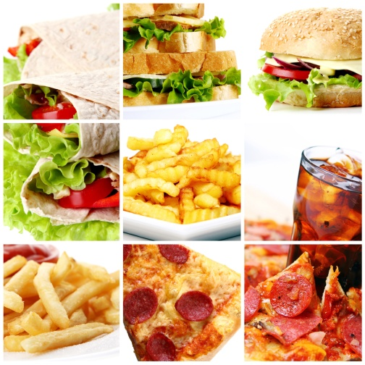
Examples of modifications customers ask for include:
- Grilled fish instead of fried
- Crumbed fish instead of battered
- Toasted bread instead of fresh
- A roll rather than 2 slices of bread.
Within reason you should strive to accommodate any reasonable request providing it doesn’t adversely affect the profitability of the item.
Check what is allowable where you work.

Special requirements
There are a wide-range of special requirements customers can ask for when ordering fast food ranging from dietary requirements through to serve sizes and the packaging of their purchase.
You must find out from your store what they can do, will allow and are able and prepared to accommodate.
When special requirements in the food itself are required remember there is usually:
- A special preparation time
- A special price.
Make sure customers are advised of this when they place their order, not when it comes time to pay.

Service Model Protocols
Service model protocol is the process by which the customers will:
- Enter the fast food outlet
- View the menu items
- Place their order requirements
- Pay for orders placed
- Receive menu items when completed
- Leave the premises.
There are many fast food outlets operating around the world and the service model protocols are the same:
- Customers enter the premises
- View the menu selection that is normally above the cash registers
- When customers have made their choice the orders are placed with cashier service personnel with all requirements
- Product is paid for and the customer waits until the order is completed
- Customers choose whether to consume the purchase in public seating area or take food to other location.

3.2 Maintain a clean customer service area

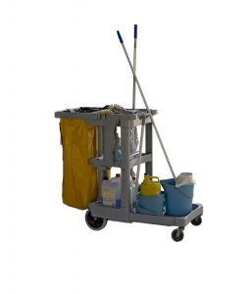
Introduction
All fast food outlets will need to be cleaned regularly and properly and have cleaning activities inspected to ensure they achieve the desired objectives.
Equipment and the premises will have to be cleaned.
In food premises the Food Safety Plan will set out store-specific requirements in relation to a cleaning schedule but customer service areas are particularly susceptible to being left messy by customers.
Unfortunately, cleaning is a job most people don’t enjoy and is therefore one often ignored let go until later or a greater emphasis might be to continue taking orders before cleaning.
Compounding this problem is the fact that we are usually asked to undertake cleaning when we least feel like doing it – at the end of our shift when we are tired and just want to go home, or go out.
The key rule about cleaning is it must be done when needed and as directed.

Customer service areas
Special attention must be paid to place where the customers are moving about:
- Cleaning of un eaten food and plates after customers vacate tables
- Cleaning of table surfaces as required
- Cleaning of floors around tables on regular basis
- Provision of facilities for cleaning up spills immediately during opening times.
Customers hesitate to occupy tables if they are not clean and ready for use when they enter the premises.

Follow cleaning schedules
An essential element of a Food Safety Plan is the establishment of a comprehensive ‘cleaning schedule’ which identifies every piece of food equipment and every food-related area that must be cleaned.
In addition, the cleaning schedule – also known as the ‘cleaning roster’ or the ‘cleaning program’ – allocates the cleaning task to:
- Who – a specified work role – not a person’s name; the person doing filling that role on the day does the job when required
- When – at a specified time – such as ‘after lunch’, ‘after dinner’, ‘as required during trade’ or ‘at the end of trade’
- When – on specified days of the week – not everything will have to be cleaned every day
- How – sets out what should be done – by providing a detailed ‘How to clean’ set of instructions for each item and area to be cleaned
- What – should be used – detailing the chemicals and the physical equipment needed to do the job properly.
Your cleaning schedule may also include ‘Why’ the item is to be cleaned, but this is not a prescribed requirement.
The allocation of cleaning jobs also enables a fairer method of allocating unpopular cleaning work.
The Food Safety Supervisor may be responsible for monitoring the cleaning schedule to ensure it is being complied with, and to revise and update it if it isn’t working as anticipated.
Cleaning in food premises must be carried out in such a way that a pattern is built up, ensuring all areas are covered by the cleaning schedule.
Putting this cleaning schedule in writing is the only way to ensure all areas are properly cleaned and sanitised as required.

The cleaning schedule must, of course, be supported by underpinning staff training, practice and supervision.

Cleaning of spills
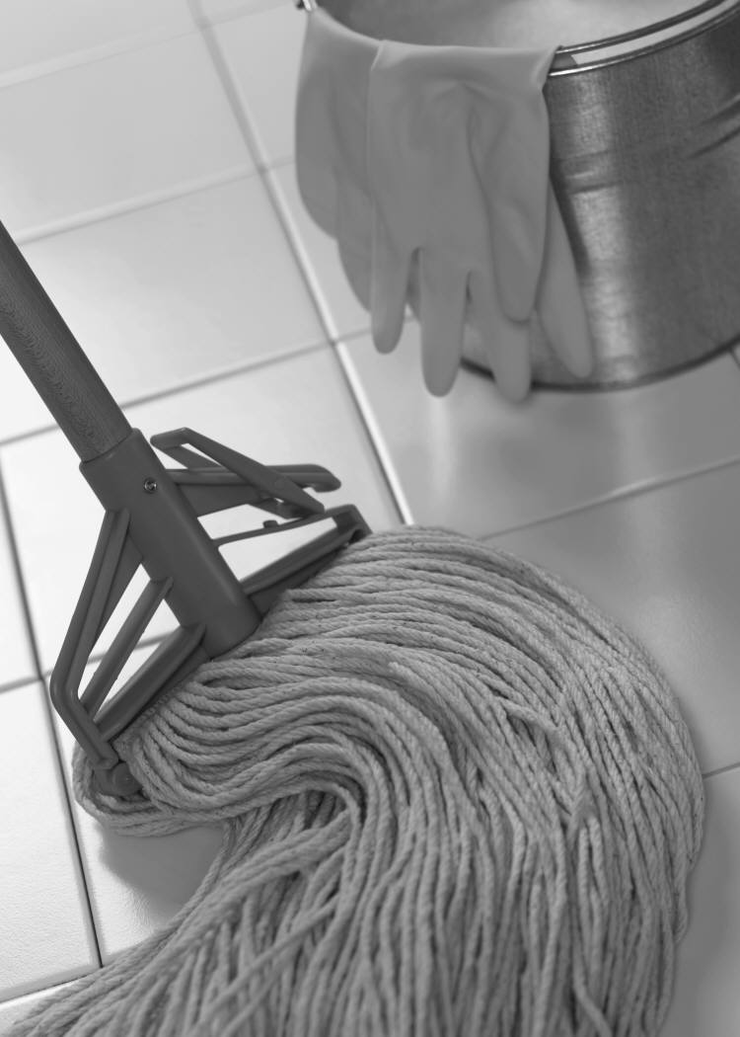
All premises must have protocols in place to clean up spills as they occur during trading times, in all areas of food preparation and customer service.
The outlet must:
- Provide suitable and sufficient equipment and utensils to clean up spillages – such as cloths, mop, bucket, broom
- Provide appropriate training in how to clean up spills – including food safety and other safety aspects (chemicals, slips and falls)
- Monitor activities so that spillages are quickly identified and addressed
- Have in place processes that isolate areas that become ‘unsafe’ until spills are cleaned up; sign and barricades go into place to warn people of potential danger.

Work Projects
It is a requirement of this Unit you complete Work Projects as advised by your Trainer.
You must submit documentation, suitable evidence or other relevant proof of completion of the project to your Trainer by the date agreed.
Student have to decide on the style of fast food outlet. Keep the choice simple.
When students have decided on the theme then the following criteria can be met.
3.1 How will the food be served to customers?
- Students will need to develop serving procedures
- How will the customer’s order the food through to the time the customers receive the food.
3.2. Maintaining cleanliness in customer service area:
- A cleaning schedule from the Food Safety Plan will need to be submitted
- How will the cleaning requirements be carried out.

Summary

Provide fast food service
Serve and present food items in line with customer volume
Mise-en-place needs to be in place
When customers enter and place their orders
Staff complete the menu items in line with enterprise standard
Customer receive order of menu items and satisfaction.
Maintain a clean customer service area
Food Safety Plan will have a comprehensive cleaning schedule on when and how all cleaning will be carried out in a food enterprises.
Customer area cleaning is defined as the area that the customers can see when they are on the premises.
This includes the kitchen area that is visible to the customers
Cleaning should be carried out on a continual basis so it is not all left until the end of day routine.

Element 4:
Maintain fast food outlet

4.1 Clean fast food area in line with establishment and equipment requirements

Introduction

All fast food outlets will need to be cleaned regularly and properly and have cleaning activities inspected to ensure they achieve the desired objectives.
Equipment and the premises will have to be cleaned.
In food premises the Food Safety Plan will set out store-specific requirements in relation to this.
Unfortunately, cleaning is a job most people don’t enjoy and is therefore one often ignored or not done properly.
Compounding this problem is the fact that we are usually asked to undertake cleaning when we least feel like doing it – at the end of our shift when we are tired and just want to go home, or go out.
The key rule about cleaning is it must be done when needed and as directed.

Food preparation areas
All equipment and food contact surfaces must, as a minimum, be cleaned (and sanitised) at the completion of each work session.
It is not sufficient to use a slicer for breakfast, lunch and dinner and clean it just once at 9:00pm; it must be cleaned after the breakfast session, after the lunch session and after the dinner session.
Likewise it is not acceptable to use a food preparation bench all day and only clean it at the end of the day – it must be cleaned and sanitised at least once every 4 hours.
In addition, many items and surfaces will need to be cleaned after each use.
Items such as fridges, freezers and dry stores must be thoroughly cleaned weekly, and have spillages cleaned up as they occur.
A scheduled cleaning program (see below) must ensure the cleanliness of all items and areas in the food preparation areas – manufacturer’s recommendations as to cleaning procedures should be followed.

Stores areas
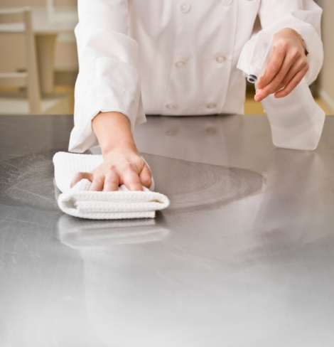
Special attention must be paid to flooring and shelving, as these are traditionally the areas where food is spilled, or dirt walked in. Regular inspections are the only way to monitor this requirement. Food items themselves should be inspected for signs of deterioration and infestation at the same time.

Food service areas
Special attention must be paid to:
- Cleaning of food service equipment after each service
- Cleaning of utensils after each session
- Cleaning of floors after each session
- Provision of facilities for cleaning up in-service spills.
It is very important to remember where the customers can see the food service area, they will be making judgements about the quality of the food from the level of cleanliness they see in this area – keep it neat, keep it clean.

Follow cleaning schedules
An essential element of a Food Safety Plan is the establishment of a comprehensive ‘cleaning schedule’ which identifies every piece of food equipment and every food-related area that must be cleaned.
In addition, the cleaning schedule – also known as the ‘cleaning roster’ or the ‘cleaning program’ – allocates the cleaning task to:
- Who – a specified person – by their name and work role
- When – at a specified time – such as ‘after lunch’, ‘after dinner’, ‘as required during trade’ or ‘at the end of trade’
- When – on specified days of the week – not everything will have to be cleaned every day
- How – sets out what should be done – by providing a detailed ‘How to clean’ set of instructions for each item and area to be cleaned
- What – should be used – detailing the chemicals and the physical equipment needed to do the job properly.
Your cleaning schedule may also include ‘Why’ the item is to be cleaned, but this is not a prescribed requirement.
The allocation of cleaning jobs also enables a fairer method of allocating unpopular cleaning work.
The Food Safety Supervisor may be responsible for monitoring the cleaning schedule to ensure it is being complied with, and to revise and update it if it isn’t working as anticipated.
Cleaning in food premises must be carried out in such a way that a pattern is built up, ensuring all areas are covered by the cleaning schedule.
As mentioned, some areas are cleaned daily, others weekly and still others less frequently – monthly and every three months in the case of, for example, cool rooms.
Putting this cleaning schedule in writing is the only way to ensure all areas are properly cleaned and sanitised as required.
The cleaning schedule must, of course, be supported by underpinning staff training, practice and supervision.


Further considerations
Management must police implementation of cleaning schedules to identify:
- If they are working or not – do they need modification?
- If enough time is being allocated to cleaning duties
- If further staff training is required
- If other, better or further cleaning equipment is required.
Remember hands must be washed after cleaning and before handling food, and cleaning schedules must be readily available so staff understand their cleaning responsibilities.

Weekly cleaning rosters
Elements of cleaning schedules will be common amongst all stores, but your cleaning schedule must be constructed to address your needs.
Below is an example of a weekly cleaning roster, allocating the cleaning of nominated areas and items to specific staff members:

After Lunch – Week Commencing: Staff responsible for all cleaning as set out below:
P = Physical cleaning such as scrubbing, D = Detergent must be used, S = Sanitiser must be used.
Cooks = C Kitchen hand = K/H
Job | Mon | Tues | Wed | Thurs | Fri | Sat | Sun
Floors | John PDS | John PDS | John PDS | John PDS | John PDS | Gary PDS | Gary
Prep Benches | Rod PDS | Rod PDS | Rod PDS | Rod PDS | Rod | Gary PDS | Gary
Grill Plates | Cas PDS | Cas PDS | Cas PDS | Cas PDS | Cas PDS | Fred PDS | Fred
Stick Blender | Rod PDS | Rod PDS | Rod PDS | Rod PDS | Rod PDS | Gary PDS | Gary
Robot Coupe | Bob PDS | Bob PDS | Bob PDS | Bob PDS | Bob PDS | Gary PDS | Gary
Kitchen Aid Blender | Bob PDS | Bob PDS | Bob PDS | Bob PDS | Bob PDS | Gary PDS | Gary
Bain-marie | Mary PDS | Mary PDS | Mary PDS | Mary PDS | Mary PDS | Val PDS | Val
Microwaves | Mary PDS | Mary PDS | Mary PDS | Mary PDS | Mary PDS | Val PDS | Val
Ovens | Cas P | Cas P | Cas P | Cas P | Cas P | Fred PDS | Fred
Bins | Bob PDS | Bob PDS | Bob PDS | Bob PDS | Bob PDS | Tom PDS | Tom
Sinks | Cas PDS | Cas PDS | Cas PDS | Cas PDS | Cas PDS | Fred PDS | Fred
Utensils, etc | All staff | All staff S | All staff | All staff | All staff | All staff | All staff
Hobart mixer | Bob PDS | Bob PDS | Bob PDS | Bob PDS | Bob PDS | Tom PDS | Tom
Salamander | Cas PDS | Cas PDS | Cas PDS | Cas PDS | Cas PDS | Tom PDS | Tom
6 Ring burner | Cas PDS | Cas PDS | Cas PDS | Cas PDS | Cas PDS | Fred PDS | Fred
Fryer |  |  |  | Kitchen hand |  |  | Fred PDS
Shelves |  |  |  |  |  |  | Fred PDS
Coolroom |  |  |  |  |  |  | Fred PDS
Dishwashing machine | Mary PDS | Mary PDS | Mary PDS | Mary PDS | Mary PDS | Tom PDS | Tom PDS
Cappuccino machine | Bob PDS | Bob PDS | Bob PDS | Bob PDS | Bob PDS | Gary PDS | Gary PDS
Coffee grinder | Bob PDS | Bob PDS | Bob PDS | Bob PDS | Bob PDS | Gary PDS | Gary PDS

Workplace cleaning instructions
Every establishment should have a set of workplace cleaning instructions to cover all the areas to be cleaned and sanitised – as new equipment is brought on-line, it must be added to this set.
The following examples are presented as an indicative guide only.
You will have to develop your own cleaning instructions with reference to manufacturer’s instructions, personal preferences, the chemicals used and the cleaning products available.

Cleaning the kitchen floor
Job description | Kitchen floor
Method – How to clean | Physically pick up large items of rubbish, scraps, equipment, etc  Sweep and spot clean identifiable problem areas such as trodden on food items  Hose down with hot water and foaming gun and squeegee  Hose again and squeegee again  Allow to air dry.
Frequency – How often | At the end of each service session, plus as required during trade.
Equipment and chemicals used | Broom  Scraper  Pressure hose – connected to hot water, auto-feed XYZ detergent and foaming gun  Squeegee.
Responsibility – Who will clean | Kitchenhand – Joe

Cleaning a Bain-Marie
Job description | Bain-marie
Method – How to clean | Remove Bain-Marie trays and wash them in sink using XYZ detergent and hot water, rinse and sanitise with undiluted XYZ  Rinse and allow to air dry  Wash main unit using XYZ detergent and hot water, rinse and sanitise with undiluted XYZ  Rinse and allow to air dry
Frequency – How often | At the end of each service session.
Equipment and chemicals used | Cleaning cloth  XYZ detergent – diluted 50:1 in sink  XYZ sanitiser – neat in spray bottle.
Responsibility – Who will clean | Trainee – Graeme

Cleaning a microwave oven
Job description | Microwave Oven
Method – How to clean | Wipe away loose debris with a clean cloth  Spot clean identifiable problem areas  Wash with XYZ detergent and hot water, rinse and sanitise with undiluted XYZ  Rinse and allow to air dry.
Frequency – How often | At the end of each service session, plus as required during trade
Equipment and chemicals used | Cleaning cloth  XYZ detergent – diluted 100:1 in sink  XYZ sanitiser – neat in spray bottle
Responsibility – Who will clean | Second Chef – Tom
Remember – the above cleaning procedures are generally applicable for items as listed. Always follow manufacturer’s instructions.
The above schedule also acknowledges not everything is required to be cleaned daily, or at the end of each service session. You will have no doubt noticed some areas are cleaned weekly, monthly or every three months.
Some areas, such as grease traps, and filters above deep fat-fryers, ranges and hot plates, are cleaned using an outside contractor.
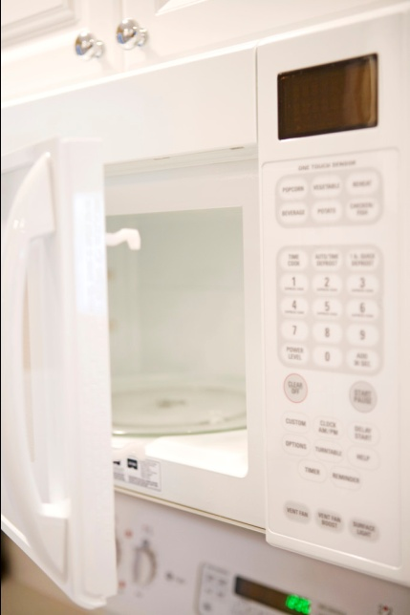
Note: You are required to read and follow the protocols laid down in your store Food Safety Plan where they differ from the above.

4.2 Undertake stock control and reordering processes

Introduction
The monitoring of stock is a standard practice in every food outlet.

Monitoring stock
Businesses need to monitor food stocks for many reasons including:
- To ensure the security of products
- To help determine profitability and business performance figures
- To ensure proper stock rotation and guard against wastage through stock loss
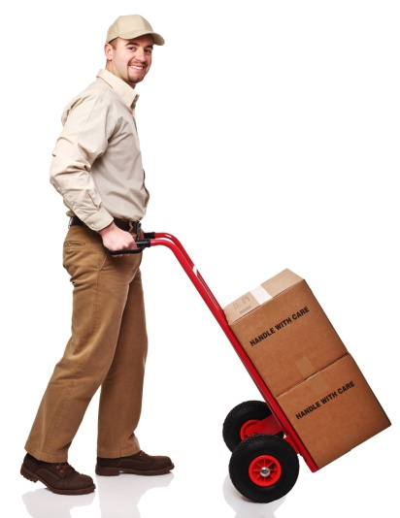
- To identify fast and slow moving lines
- To determine re-order times and levels.
It is part of operating any fast food outlet that you develop a ‘working knowledge’ of what stock you have ‘on hand’ at any one time.
This knowledge should extend to knowing:
- What sort of stock is available
- How much of each item is in stock
- Where each item is ordered from
- How to order each item
- The sizes and quantities of stock normally ordered
- How long each item will take to be delivered – that is, the lead time from placing the order to receiving the delivery.
There are two basic ways of monitoring stock levels.
- Analysis of documentation including computer-based records
This is not very common in small fast food outlets but is becoming an increasingly common option.
Use of documentation or records to monitor stock is useful because it enables the job to be done quickly and at one location (in the office or at a computer).
Certainly if actual stock movement genuinely reflects the record-based movement, this is an effective way of monitoring stock but it has a potential disadvantage or limitation in that the figures in the records do not always accurately and honestly reflect exactly what occurred in practice.
In practice:
- Items are stolen
- Items are given away
- Products become damaged by pests
- Goods become unfit for consumption due to incorrect storage
- Staff give smaller or larger portions than directed
- Products become unsaleable for many reasons
- Items are legitimately given away by management free-of-charge – as promotions, complimentary goods or donations
- Food is wasted during the preparation, cooking and service processes.
All of these factors combine to indicate actual stock-on-hand is often not what the records say it should be.

2. Visual inspection of stock
In smaller fast food operations (and in many larger ones too) the best way to monitor stock is to do a visual inspection of it.
This involves checking all locations where stock is kept (storage areas, preparation and service areas) and physically counting the items and quantities actually presented.
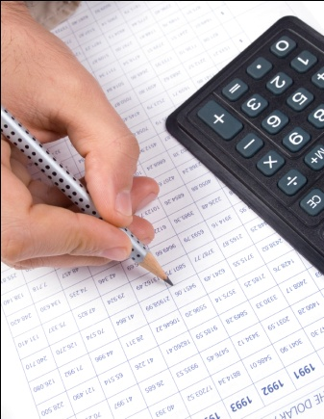
This ‘stock count’ may then be compared against a record of some kind to determine operational matters relating to profitability, theft, wastage etc.

Accounting for stock
The above notes have indicated many things can happen to stock in a fast food operation, apart from it being sold.
Where you have responsibility for accounting for stock you will be expected to be able to explain to management what has happened to ‘their’ products.
Really, this is no different from being responsible for accounting for money taken over the counter.

Why is there a need to worry about accounting for stock?
Management will always have some idea of the level of profit or return they expect from the stock they have sold. This profit is the reason they are in business – to make money.
There are many sophisticated ways of businesses working out what their return should be but they are all variations on a very simple theme.
For example:
A fast food operator knows they buy a carton of 3 x 5kg bags of frozen chips for $30 a carton, that’s $10 per bag.
Let’s say they’ve bought 10 cartons to meet the expected need at a football match they are catering for.
The operator also knows they serve a 200gm serve of chips every time they serve chips at $3 per serve.
The simple maths indicates for every box of chips they serve they can expect:
- 5 serves per kg, multiplied by 5kgs per bag = 25 serves per bag multiplied by 3 bags per carton = 75 serves per carton
- 75 serves at $3 = $225 revenue for each carton of chips sold.
If the fast food outlet sells their 10 cartons of chips, then there needs to be $2,250 in the cash register or something’s wrong.

You can see how it easy it would be to do the same calculations for all the other products sold too – drinks, hamburgers, fish, etc, it is all simple arithmetic.
The operator of any fast food outlet will be looking to make sure they either have:
- Product
- Cash.
Using the above example, we sold all 10 cartons of chips so there was no stock left – all we had was cash.
If we had only served 5 cartons of chips, then management will be looking to see they have:
- 5 cartons of chips left
- $1,125 in the cash register.
Things that can affect the return a fast food outlet might get from its bag of chips.
You might need to monitor what is happening to stock so the outlet continues to get its $225 per carton of chips but there may be situations where management is prepared to accept a lesser return than this and factor in a ’shrinkage factor’.
This shrinkage factor may allow for the realities of the workplace and make allowances for:
- Staff eating a few chips themselves
- Inconsistent serve size that favours the customer
- A few ‘freebies’ the supervisor gives away to special customers.
Regardless of what happens to the chips, if you are responsible for accounting for them you need to be able to explain at any given time when there is a problem:
- What happened to missing stock
- Why it happened
- Who was responsible
- What was done to limit the problem
- What has been done to try to ensure it doesn’t happen again.

Re-ordering stock
Your role may involve ordering stock – make sure you never order anything unless you have specific permission to do so.
You may be required to:
- Use your initiative and order what you think is required as it becomes necessary to order it
- Only order when advised to do so by management
- Order stock to replace what has been used.
Check with your supervisor to see what applies where you work.
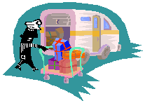
Orders may be placed:
- By phone
- By fax
- Over the internet
- In person at the suppliers
- In person with a sales rep (representative) from the supplier who calls in to the outlet.
You may be required to lodge all orders through head office.
When placing orders make sure you:
- Give the correct delivery instructions – time and place required
- Give the correct account details – who it is to be charged to
- Order only what you are authorised to order.

4.3 Identify and report maintenance issues to appropriate personnel

Introduction
There is direct relationship between how ell equipment is maintained and how well it performs.
There is also a clear link between well maintained equipment and the level of breakdown it experiences – well maintained equipment breaks down far less than poorly maintained equipment.

General requirements
Keeping food equipment clean is a prime maintenance requirement.
Any food equipment allowed to form a build-up of food is more likely to fail, not operate safely, present a food safety hazard, or not operate as intended or required.
The following points will assist:
- Do regular visual inspections of equipment and clean when needed
- Advise management when any item appears not to be working properly
- Be alert to ‘warning signs’ such as:
- Tell-tale, unusual noises
- Equipment taking ‘too long’ to warm or heat up
- Strange noises
- Smell of smoke or an ‘electrical’ smell that comes with over-heated equipment
- Equipment that starts to shake or vibrate
- Sparks or electric shocks
- Missing or broken parts.
There is little apart from replacement of a restricted range of parts and basic lubrication that can be done by operators to service or maintain their equipment.
It is essential you keep any service manual delivered with new equipment so you can refer to it later for help when trouble-shooting a problem.

Repairs and maintenance

For refrigeration items, where temperatures are reading outside the required ranges the remedial action may simply be to get a service technician to come in and fix the unit (repair the area where the leak is, re-gas the refrigeration, repair the controls, replace the fan belt, etc).
You must also check with your supervisor to determine:
- When you have authority to call in a service company
- The names and contact details for service companies you use.
If an item requires attention it may be you will have to arrange a service call immediately regardless of the day of the week, or the time of the day.
In other situations it may be possible to wait.
Use your judgement about how urgent the matter is, what alternatives you have available to you and how much the service call is likely to cost.

Work Projects
It is a requirement of this Unit you complete Work Projects as advised by your Trainer.
You must submit documentation, suitable evidence or other relevant proof of completion of the project to your Trainer by the date agreed.
Student have to decide on the style of fast food outlet. Keep the choice simple.
When students have decided on the theme then the following criteria can be met.
4.1 Clean premises:
- Develop a cleaning schedule for the entire fast food outlets
- List of all equipment that needs to be cleaned:
- When
- Who
- How
- With what.
4.2. Stock Control Process and re-ordering:
- Students are to set a par stock requirement for all menu item ingredients
- Set up a process which instructs the manager of how to maintain required stock levels.
4.3. Reporting Maintenance Issues:
- All enterprises will need to have a process on how to report any maintenance requirements
- Students need to develop a form that details instructions on the following
- What is the maintenance issue?
- Where is the problem located?
- Who is reporting the defect?
- When is the issue being reported, date.

Summary

Maintain fast food outlet
Clean fast food area in line with establishment and equipment requirements
Cleaning will be implemented according to the cleaning schedule
The cleaning schedule is part of the Food Safety Plan
Cleaning process needs to be documented to show that Food Safety Plan commitment is being met.
Undertake stock control and reordering processes
Regular stock takes matches number of sales to amount of product being purchased
Regular stock takes assist to identify slow moving items
Possibility of pilfering by staff
Develops new methods of reordering.
Identify and report maintenance issues to appropriate personnel
Report any maintenance requirements immediately
Non operational machinery actually cost an enterprise money
Staff normally find alternative ways to achieve outcomes when machinery become too hard to handle
These alternatives can have detrimental effects on final product and can also cause rate of production to become inefficient.

Element 5:
Store food items

5.1 Store fresh and/or Cryovac items correctly

Introduction

‘First In – First Out’ (F.I.F.O)
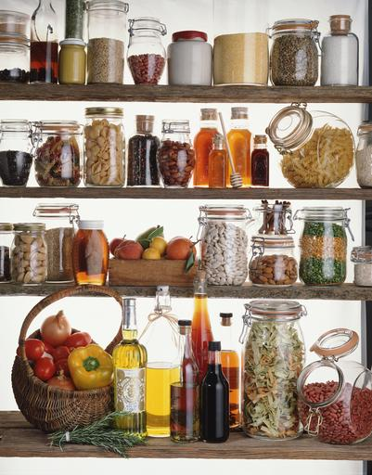
All food should be stored and used on a First In – First Out basis.
This means that the food delivered earlier is used first.
Fish delivered on Monday should be used before fish delivered on Thursday. Wafer biscuits delivered in February should be used before wafer biscuits delivered in March.
Maintenance of a ‘First In – First Out’ system requires food handlers to organise both the collection and storage of foods.
When putting a delivery of food into store – either dry store or refrigerated – it is necessary to put the latest arrivals at the back and to move the earlier arrivals to the front.
Dry goods should always be stored and used in order of the ‘Use-By’ or ‘Best Before’ dates on the packages.
Fresh foods are not delivered with these dates so it is helpful if fresh foods are tagged with the date of delivery and stored in order of delivery. Food under refrigeration should be moved forward when a new delivery arrives, and the newly delivered food should be stored in separate, clean containers behind the food that is already there.
To ensure that First In – First Out is always implemented, it is advisable to mark every delivery of food with the date of delivery. This should be done in large, dark writing, and the date should always be highly visible in the store.
Foods that are frozen should also be used on a First In – First Out basis. Frozen foods should be tagged with the date that they were delivered and the date they were frozen.
Ensure each product is stored in accordance with the manufacturer’s guidelines outlined on the label or the packaging.

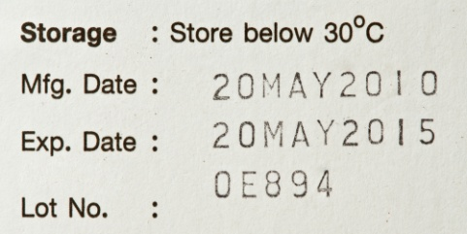
Cold storage
Refrigerators, freezers and cool rooms are known as ‘cold storage’ areas.

Labelling
Foods that require storage in either a refrigerator or freezer should be labelled with the date of delivery and the date of freezing. In respect of frozen foods, it may also be necessary to identify what the food is, because often frozen foods are hard to identify.

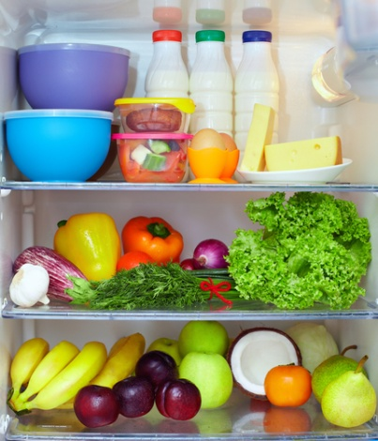
First In – First Out
Foods in the refrigerator or freezer should be used on a First In – First Out basis.
For example, fish that is in the refrigerator should be moved to the front of the shelf when a new delivery of fish is made. The same procedure should be observed for all foods.

Cold air circulation
The cold air in the refrigerator or freezer needs to be able to circulate around the food to keep it all cold.
For this reason, food in cold storage should not be packed tightly – the cold air cannot circulate around the foods freely.
Meats and fish, in particular, should be laid out on trays in low stacks, and not kept in high stacks or in large plastic bags.

Hot foods in cold store
Large amounts of hot food should not be placed in the cool room, refrigerator or freezer.
If a large amount of hot food is placed in the refrigerator, then the outside cools quickly, but the inside takes a very long time to cool. Therefore, the inside may be in the Temperature Danger Zone for an unsafe period of time.
Before refrigeration, hot food should be placed in small, shallow containers to cool.
Stirring the hot food frequently will allow the cool air to circulate around the food and cool it down quickly.
Placing large amounts of hot food in a refrigerator or freezer will raise the temperature of the refrigerator. This may place all other foods in the cold store at risk of entering the Danger Zone.
Hot food in the cold store will also cause moisture condensation, which may affect other foods stored nearby.

Refrigerating or freezing hot food
Hot food must not be put directly into a cool room, refrigerator or freezer – the food must first be cooled.
A two-step rule applies:
Step 1: Cool hot food down from 60°C to 21°C within 2 hours of removing the food from the stove, oven or other cooking unit.
Step 2: Once the food has reached 21°C it should be placed into a refrigerator/cool room, and then cooled to 5°C (or below) within a further 4 hours.
In addition, once the food has reached 5°C, it can be put in the freezer.

Cross-contamination
The most common cause of contamination in the kitchen is cross-contamination from raw to cooked foods.
If possible, place raw foods and cooked foods in separate refrigerators. This will help reduce the possibility of cross-contamination.
If the same refrigerator is used for both raw and cooked foods, always place the cooked food on a shelf above the raw food. Never put cooked food below raw food and never put raw and cooked foods together.
Raw food (particularly meat) may drip blood and juices onto the food below, thus providing the perfect opportunity for cross-contamination.

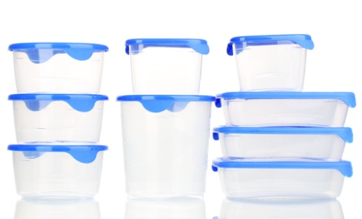
Containers
The containers in which food, especially uncooked food, are stored should be designed to avoid leakage of any blood or juices.
This means that meat trays or fish trays should not be flat, and should be deep enough to contain any juices or blood that may seep out of the fish or meat.

Surfaces
The walls, floor and shelves in the cold store should be clean, free of rust and cracks and covered with a material like paint or linoleum.
Little cracks or chips in the paint will provide an opportunity for microorganisms to grow and reproduce.
It is hard to clean inside these cracks and crevices, and if blood or food particles drop into them, a very favourable environment will be provided.
Also be aware that walk-in cool rooms may have shelves that quickly deteriorate with plastic peeling away and posing a risk to food: the potential for this to occur should be monitored and where noticed, one of many companies that resurface these shelves must be contacted to undertake appropriate corrective action.

Cleaning
Constantly check for moulds on the refrigerator shelves, walls and floor, and on the stored foods.
Mouldy food should be discarded immediately, along with any food that has been spoilt by contact with the mouldy food.
If mould is detected on the shelves, walls or floor, sanitisation methods should be employed immediately.
As refrigerators and freezers are used to store potentially hazardous or high risk foods, food handlers need to be particularly vigilant in attending to the cleaning, sanitising and maintenance of cold stores.
Every food premises should have a roster or schedule for the thorough cleaning and sanitising of the cold store on a regular and very frequent basis. Freezers do not require to be cleaned as often as refrigerators.
The most important element of cold storage is that it is cold.
Refrigerators and freezers should be checked on a regular basis to ensure that the temperature is sufficiently cold:
- Refrigerator temperatures are between 4ºC to 0ºC.

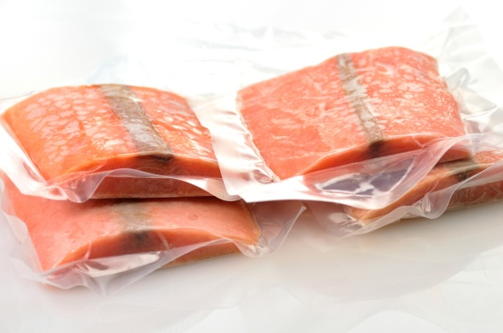
Vacuumed Sealed products
Vacuum sealing foods is the process of eliminating all the air within a bagged product.
This eliminating of air reduces the oxygen in the air and reduces the bacterial activity when product is chilled to below 3°C.
This process extends the life of the product without freezing.
When products like beef are vacuum sealed the storage requirements require them to be chilled at all time:
- Store with the fat side up so the blood does not pool at the bottom and stain the fat
- Store in single layers to help keep product chilled
- Store product like this extends the life of product and the enzyme activity has a tenderising effect on meat structure.
Vacuum sealing is sometimes called ‘Cryovac’. Cryovac is a trade name, not a technique.
Recommendation:
If product is delivered vacuum sealed and the seal is broken then the product should be rejected.
If kitchen staff find previously vacuum sealed product have lost their seal then they should be opened and product used immediately.

5.2 Prepare and maintain correct thawing of food items

Thawing
Planning in advance is required when defrosting or thawing food from a freezer.
Most food poisoning microorganisms die when frozen; however, the spores formed by microorganisms are not destroyed by freezing.
The spores lie dormant in the food in the freezer. When the food is removed from the freezer and the temperature rises, the spores become active and the microorganisms begin to grow and reproduce.
The shorter the period of time spent in the Temperature Danger Zone, the lower the chance of food poisoning.
Thawing food incorrectly will provide an ideal environment for microorganisms to grow and reproduce. It is important that food is not held in the Temperature Danger Zone for a long period of time.
Food is never safe in the danger zone (remember danger zone 5ºC – 60ºC) and must be served as quickly as possible or correctly stored away after thawing.
Food that has been properly stored in the freezer will be in small quantities where possible. Do not stack food parcels in a pile for thawing.
When food is being thawed, it should be placed so as to allow for thorough air circulation. This assists in reducing the time required for thawing.
Sometimes it is impossible to freeze foods in small quantities, such as a large roast or turkey. Special care should be taken to ensure that the thawing process is undertaken in as short a period of time as possible, and that when the food is cooked that the interior of the food reaches at least 75ºC for at least 1 minute.

It is dangerous to thaw food on a bench or in an oven
With this method, the food, or parts of it, remain at danger zone temperatures for unsafe periods of time. The outside of the food will start to thaw and will reach the danger zone while the interior is still frozen. The outer thawed parts will provide a favourable environment for microorganism activity, while the time elapses for the thawing of the interior.
This scenario is even more probable when one considers that the outer parts of the food have come into contact with hands, benches and/or vermin (e.g. flies). Microorganisms in the environment are thus likely to have been transferred to the outer parts of the food.
The only safe thawing methods are:
- Under refrigeration – food from the freezer thaws slowly: this process can take up to two days, therefore planning is essential
- In a microwave oven – if time is limited
- Under cold running water – at 20ºC or below: this means that it is not legal to allow frozen food items to sit in a sink or bowl of water to thaw out.

5.3 Store fast food products appropriately in correct containers

Food containers
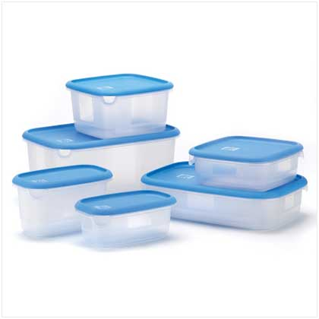
Containers in which food is stored must be:
- Clean
- Sanitised
- Dry
- Free of cracks and chips
- Appropriate for the type of food stored.

Cleanliness
New containers should never be used without being first cleaned, sanitised and dried. This ensures that any microorganisms, vermin or foreign objects are removed.
Containers should never be reused without being thoroughly cleaned, sanitised and dried. It is unsafe to reuse ‘single use’ containers. They are not designed to be easily cleaned and sanitised.
Never store food in containers that have been used to store chemicals, cleaners or poisonous substances.
Empty containers should be stored in a clean and vermin-proof environment. They should be stored upside down to assist the drying process, and to stop microorganisms, foreign objects and vermin from falling into the containers.
Containers should be inspected immediately prior to use to ensure that they are clean and free of foreign objects or vermin, and uncontaminated by foreign odours.

Damaged containers
Containers that are cracked and chipped or pitted should be discarded.
Cracks and chips harbour microorganisms and spores. Metal containers may be rusted or flaking, and aluminium containers may be pitted.
These defective areas provide favourable environments for microorganisms.
Any food stored in defective metal containers may react with the containers to chemically alter the food.
For example, Alzheimer’s disease is linked with chemical poisoning from the use of aluminium cookware.

Proper containers for particular foods
Damaged or cracked containers can result in loss of the food from the container.
Food leakage is a major source of cross-contamination, especially in the refrigerator. Dry food that spills from its container attracts vermin and microorganisms.
Furthermore, spilt food can cause workers to fall. This is a common occupational health and safety hazard for food handlers.
Some foods should only be stored in particular types of containers.
For example, plastic containers used for the storage of fish will absorb a fishy odour. Fish is best kept in a metal container (e.g. stainless steel):
- If a plastic container has been used for fish, it cannot later be used to store any other type of food.
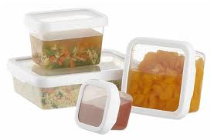
Containers that are to be reserved for particular food types should be appropriately labelled.
Some foods require airtight containers to maintain maximum quality, e.g. both sweet and dry biscuits and potato crisps.
Food should never be stored in aluminium containers, especially if the containers are pitted. If aluminium cookware is used, the food should be removed to another container for storage.
Similarly, canned food should never be kept stored in the opened can. Once the can has been opened, the food should be placed in an appropriate container.
This is because the food will react chemically with the container.
Plastic containers should not be used in the microwave unless they are clearly marked as being microwave safe.
Neither should plastic wrap that is not marked specifically as ‘microwave safe’.
This is because the microwave breaks down the plastic and produces toxins that are poisonous.

5.4 Label fast food products correctly

Introduction
Labels used to identify foods are required to have the following information:
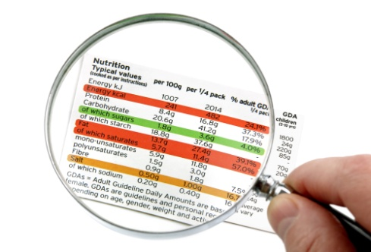
- Name of the product
- Date of manufacture
- Recommended use by date
- Name of person who manufactured product
- Name of section person worked; if large organisation.
This label that would be used for general storage in kitchen.

Labels for public viewing in store
Label placed on food for the public to choose from the menu:
- Name of the menu item
- Price per unit
- Weight may be included; normally not needed.
Labels required on products that are packaged and will be sold in other premises:
- Name of the product
- Description of the food
- Date of manufacture
- Use by date
- Contact details of manufacturer:
- Telephone Number
- Website details
- Allergens that may be present in product nuts, soy, gluten
- Storage requirements, temperature requirements for storage
- Nutrition details
- Ingredients list in descending order
- Percentage labelling
- Food additives and relevant E Numbers
- Country of origin: Product of Australia; made with local and imported ingredients.
All information on the label must be the truth.
Any correct information on label can be cause for food recall being imposed.

5.5 Ensure correct conditions are maintained for freshness and quality
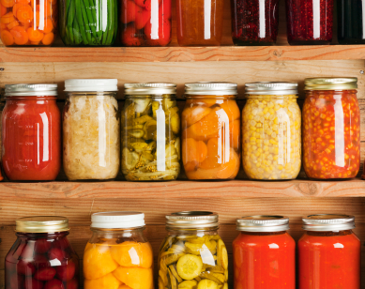
Maintaining freshness and quality in foods from fast food outlets is determined by the following.

Storage conditions
All high risk foods need to be stored at temperature that will minimise the growth of potentially dangerous bacteria:
- Store below 5°C for up to 4 days.
For longer storage high risk foods it is recommended that foods be frozen:
- Freeze below minus 18°C (-18°C).
When food is placed into storage it must be protected from contamination:
- Cover food with impervious product, (plastic wrap).

Foods prepared for sale
Foods prepared for sale must be kept in a condition that will not be detrimental to condition of final product.

Food served hot
If it is to be served hot then it must be kept hot and not allowed to dry out due to dehydration:
- Solution: Do not store hot for long period of time
- Cook product to order or cook set number per 15 minute period.

Food served cold:
Food can be preportioned and kept chilled until required. Pre-portioned product in containers need to be label marked with date of packaging. Food can be served as required.

Food displayed at Room Temperature
Food to be served at room temperature can be displayed protected from contamination:
- Covered in plastic protection.
The plastic protection to minimise dehydration and slow down staling process.
A problem with this is the possibility of mould growth due to moist conditions inside with warmer ambient temperatures.

Work Projects
It is a requirement of this Unit you complete Work Projects as advised by your Trainer.
You must submit documentation, suitable evidence or other relevant proof of completion of the project to your Trainer by the date agreed.
Student have to decide on the style of fast food outlet. Keep the choice simple.
When students have decided on the theme then the following criteria can be met.
Student will need to write a report outlining the following procedures.
5.1 How does the fast food outlet intend to store perishable foods?
- List all requirement and processes that will be implemented.
5.2. Carry out the thawing of foods:
- Describe procedure (SOP), Standard Operating Procedures for the thawing of frozen foods.
5.3. Describe how products will be stored in containers:
- Outline requirements for the type and condition of containers to be used for storing foods.
5.4. Describe labelling requirements for stored foods:
- List all labelling requirements for stored foods.
5.5 What condition will be implemented to maintain freshness?
- Describe processes that will be put into place to maintain freshness and eating quality in all products on menu list.

Summary

Store food items
Store fresh and or vacuum packed items correctly
All fresh products need to be stored at a temperature that will minimise the growth of potentially dangerous bacteria
Store below 5°C for up to 3 days
Cover all product to protect from contamination.
Prepare and maintain correct thawing of food items
All frozen products are best thawed in controlled environment of the coolroom that has a consistent temperature of less than 5°C.
When thawed product should be used immediately.
Store fast food products appropriately in correct containers
Containers need to be food grade
Need to be impervious to moisture
Must be able to be sealed
Must be in good conditions.
Label fast food products correctly
Labels need to be legible
Must have all information required
Name of product
Date of manufacture
Name of person who made product
Use by date.
Ensure correct conditions are maintained for freshness and quality
Keep product protected from environment
Produce product as required.

Presentation of written work

1. Introduction
It is important for students to present carefully prepared written work. Written presentation in industry must be professional in appearance and accurate in content. If students develop good writing skills whilst studying, they are able to easily transfer those skills to the workplace.

2. Style

Students should write in a style that is simple and concise. Short sentences and paragraphs are easier to read and understand. It helps to write a plan and at least one draft of the written work so that the final product will be well organized. The points presented will then follow a logical sequence and be relevant. Students should frequently refer to the question asked, to keep ‘on track’. Teachers recognize and are critical of work that does not answer the question, or is ‘padded’ with irrelevant material. In summary, remember to:
- Plan ahead
- Be clear and concise
- Answer the question
- Proofread the final draft.

3. Presenting Written Work
Types of written work
Students may be asked to write:
- Short and long reports
- Essays
- Records of interviews
- Questionnaires
- Business letters
- Resumes.
Format
All written work should be presented on A4 paper, single-sided with a left-hand margin. If work is word-processed, one-and-a-half or double spacing should be used. Handwritten work must be legible and should also be well spaced to allow for ease of reading. New paragraphs should not be indented but should be separated by a space. Pages must be numbered. If headings are also to be numbered, students should use a logical and sequential system of numbering.
Cover Sheet
All written work should be submitted with a cover sheet stapled to the front that contains:
- The student’s name and student number
- The name of the class/unit
- The due date of the work
- The title of the work
- The teacher’s name
- A signed declaration that the work does not involve plagiarism.
Keeping a Copy
Students must keep a copy of the written work in case it is lost. This rarely happens but it can be disastrous if a copy has not been kept.
Inclusive language
This means language that includes every section of the population. For instance, if a student were to write ‘A nurse is responsible for the patients in her care at all times’ it would be implying that all nurses are female and would be excluding male nurses.
Examples of appropriate language are shown on the right:
Mankind | Humankind
Barman/maid | Bar attendant
Host/hostess | Host
Waiter/waitress | Waiter or waiting staff

Recommended reading
Cracknell.H,

Kaufmann.R; 2009 (3rd edition); Practical Professional Cookery; Cengage Learning
Dodgshun. Graham,Peters.M; 2012 (6th edition);Cookery for the Hospitality Industry; Cambridge University Press
Drysdale.John; 2008 (4th edition); Profitable Menu Planning; Prentice Hall
Fields, Roger; 2007; Restaurant Success by the Numbers: A Money-Guy's Guide to Opening the Next Hot Spot; Ten Speed Press
Garvey, Michael; 2011 (2nd edition); Running a Restaurant For Dummies; For Dummies
Graham Dark, Deirdre McLean & Sarah Weatherhead; 2011 (2nd edition); Kitchen Operations; Pearson Australia
Gregoire, Mary B; 2013 (8th edition); Foodservice organisations: a managerial and systems approach; Pearson
Feinstein. Andrew H, Stefanelli. John M; 2009 (2nd edition); Purchasing for Chefs: A Concise Guide; Wiley
Matzen, Tom; Harrison, Marybeth; 2004; Start and run a coffee bar, 2004; Self Council Press
McVety.P, Ware.B, Ware.C; 2

008 (3rd edition); Fundamentals of Menu Planning; Wiley
Melaniphy, J; 1992; Restaurant and fast food site selection; John Wiley and sons
Miltiandes, Michael; 2004: How to operate a successful café or restaurant; BAS Publishing
National Restaurant Association; (2006, 6th edition); ServSafe Manager; Prentice Hall
Scanlon.N; 2012 (4th edition); Catering Management; Wiley
Traster.Daniel; 2013; Foundations of Menu Planning; Prentice Hall
Walker, John; Lundberg, Donald; 2005; The Restaurant, from conception to operation; John Wiley and Sons
Waters.D; 2003 (2nd edition); Inventory Control and Management; Wiley

Trainee evaluation sheet

Operate a fast food outlet
The following statements are about the competency you have just completed.
Please tick the appropriate box | Agree | Don’t Know | Do Not Agree | Does Not Apply
There was too much in this competency to cover without rushing.
Most of the competency seemed relevant to me.
The competency was at the right level for me.
I got enough help from my trainer.
The amount of activities was sufficient.
The competency allowed me to use my own initiative.
My training was well-organized.
My trainer had time to answer my questions.
I understood how I was going to be assessed.
I was given enough time to practice.
My trainer feedback was useful.
Enough equipment was available and it worked well.
The activities were too hard for me.

The best things about this unit were:

The worst things about this unit were:

The things you should change in this unit are:

Trainee Self-Assessment Checklist
As an indicator to your Trainer/Assessor of your readiness for assessment in this unit please complete the following and hand to your Trainer/Assessor.

Operate a fast food outlet
 |  | Yes | No*
Element 1: Plan for fast food production
1.1 | Identify large and small equipment requirements for menu and volume
1.2 | Identify staff requirements
1.3 | Plan a menu to meet establishment and client requirements
1.4 | Plan workflow and production schedules
1.5 | Prepare standard recipes for menu items
Element 2: Prepare, cook and hold items for fast food outlet
2.1 | Use appropriate preparation and cooking methods
2.2 | Use appropriate equipment
2.3 | Follow food safety requirements
2.4 | Hold menu items
2.5 | Reheat menu items
Element 3: Provide fast food service
3.1 | Serve and present food items in line with customer volume
3.2 | Maintain a clean customer service area
Element 4: Maintain fast food outlet
4.1 | Clean fast food area in line with establishment and equipment requirements
4.2 | Undertake stock control and reordering processes
4.3 | Identify and report maintenance issues to appropriate personnel
Element 5: Store food items
5.1 | Store fresh and/or Cryovac items correctly
5.2 | Prepare and maintain correct thawing of food items
5.3 | Store fast food products appropriately in correct containers
5.4 | Label fast food products correctly
5.5 | Ensure correct conditions are maintained for freshness and quality

Statement by Trainee:
I believe I am ready to be assessed on the following as indicated above:
Signed: | _____________________________ | Date: | ______ / ______ / ______
Note:
For all boxes where a No* is ticked, please provide details of the extra steps or work you need to do to become ready for assessment.





